Furniture Management System Requirements Specification

Version 3.0

June 05, 2019

Documentation done by:

Dhimitraq Stambolliu

Eda Muka

Goldena Hoxhaj

Kejsi Kallmeti

Marina Piro

Pulia Letizia Naska

Accepted by:  
Igli Hakrama

Table of Contents

1. Executive Summary 4

1.1 Project Overview 4

1.2 Purpose and Scope of this Specification 4

2. Product/Service Description 5

2.1 Product Context 5

2.2 User Characteristics 5

2.3 Assumptions 6

2.4 Constraints 7

2.5 Dependencies 7

3. Requirements 7

3.1 Functional Requirements 7

3.2 Non-Functional Requirements 10

3.2.1 Product requirements 10

**3.2.1.1** **User Interface requirements** 10

**3.2.1.2** **Usability** 11

**3.2.1.3** **Efficiency** 11

Performance 11

Space Requirements 11

**3.2.1.4** **Dependability** 11

Availability 11

Portability 11

Reliability 12

Maintainability 12

º Monitoring 12

º Maintenance 12

**3.2.1.5** **Security** 13

Protection 13

Authorization and Authentication 13

Data Management 13

3.2.2 Organizational Requirements 14

**3.2.2.1** **Operational Process** 14

**3.2.2.2** **Development Process** 15

**3.2.2.3** **Network and Hardware Interfaces** 15

3.2.3 External Requirements 15

**3.2.3.1** **Regulatory requirements** 15

**3.2.3.2** **Ethical Requirements** 16

**3.2.3.3** **Legislative Requirements** 16

3.2.4 Domain Requirements 16

4. User Scenarios/Use Cases 17

4.1 User Scenarios 17

4.1.1 User scenarios extended 18

4.2 Use cases 27

5. System Design/Diagrams 36

5.1 Use case diagrams 36

5.2 Activity diagrams **Error! Bookmark not defined.**

5.3 State Diagrams 46

5.3.1 Admin 46

5.3.2 CFO 47

5.3.3 HR state 48

5.3.4 Sales agent 49

5.3.5 Operations’ manager 50

5.4 Sequence diagrams 51

5.4.1 Create income statement 51

5.4.2 Create inventory 52

5.4.3 Create user **Error! Bookmark not defined.**

5.4.4 Update user **Error! Bookmark not defined.**

5.5 Collaboration diagrams 53

5.5.1 Generating income statement 53

5.5.2 Access inventory 54

5.6 Data Flow Diagram: 55

5.6.1 DFD - Level 0 55

5.6.2 DFD - Level 1 56

5.6.3 DFD - Level 2 57

5.7 Entity Relationship Diagram 58

5.7.1 Entity Relationship Diagram without attributes 58

5.7.2 Entity Relationship Diagram with attributes 59

5.8 Class diagram 60

5.9 Object diagram 61

5.10 Deployment diagram 62

5.11 Component diagram 63

# Executive Summary

## Project Overview

Taking in consideration the difficulties joineries cope with several tasks everyday, it seemed necessary to create a management system, which will consist of handling different tasks including those inside and outside of the furniture store. Furniture Management System intends to create a multitasking software for every employer at anytime while they are working.

The platform will be built in the way that it will join all the requirements putting those together and providing a practical and trustful way of managing their stopovers, purchases, payment history and order plans in a well-organized and functional system.

So, we think it is significant to have a well-built communication bridge between the administrator, user's needs and our conception. Since we aim to improve our system in a continuous time, these 3 elements need to be well-connected with each other.

Moreover, we have also thought to provide two users in our management system in that way it will be accessible easily by them. In order to ease the design components, the system should apply different technologies such as PHP, Android etc. FMS, the software which will be provided to them, will make every step of work easier to be executed and solve many issues relating to production, finance, human resources, sales.

## Purpose and Scope of this Specification

The purpose of this specification is providing a detailed information, with all the components and elements for our web application. Regarding the target audience, it will be described in further details followed by the requirements and its interface.

Moreover, the intended audience of the software system is the administrator and the designer of the system. This software system will improve efficiency, effectiveness and productivity of the management system. FMS is built to:

* Grow e-commerce sales and drive innovation
* Improve control over purchasing and finance
* Reduce raw materials, inventory and labour costs
* Gain 360-degree visibility across its operations
* Reduce paperwork and to automate order processing

# Product/Service Description

## Product Context

Klajdi Furniture is a complex manufacturing company that includes many departments and it follows many operation processes to be a successful company. In order for the company to improve and to make its performance better, we will create a software.

Furniture Management System will be a system that collects and analyzes all the processes. This system will be of best interest to the company on the grounds it will help to keep their assets, their investment on their staff, materials, suppliers and on other business processes.

The software will facilitate the users of the system in decision making and will reduce time consumption. It will include information about suppliers, employees, products, sales, invoices, salary, customers, reports and production process.

## User Characteristics

Users that are going to have access on the software are:

1. **Administrator:**
   * Can add new users
   * Can manage the users’ login credentials
   * Will give access to those users
   * Will have access to everything in the system
2. **Chief Financial Officer(CFO):**
   * Can register products
   * Can add brands
   * Can add category
   * Can register suppliers
   * Will generate monthly reports
3. **A human resources' specialist**
   * Can add new employees
   * Can manage existing employees
   * Payroll management
   * Job evaluation
4. **Sales agent**
   * Register customers
   * Will keep information of the customers
   * Will keep information for every sale
   * Will do reports regarding sales
5. **Operations manager**
   * Add raw materials
   * Keep labor costs
   * Keep manufacturing overheads
   * Register machineries
   * Keep work instructions
   * Hold data of progress of the manufacturing process

## Assumptions

* It is assumed that the system will be accessed from web browser on the computers, cell phones or tablets as long as they have connection to the internet.
* It is assumed the users are familiar with English language.
* It is assumed that the administrator will be the first user that can have access in the system , and afterwards the administrator will add the other users.
* It is assumed that the system will be easy to use from each user, even for those using the system for the first time.
* It is assumed that only sale agent will have access over customer information and this information is fully confidential.
* It is assumed that every month the CFO will prepare reports over the activities happened over this time.
* It is assumed that these reports will be viewed by the administrator for him to make managerial decisions.

## Constraints

* Every user should have a personal device during working hours in order to access the web application.
* Since it will be a web application and get the data from database over the internet, itis essential to have stable internet connection to have a full-time access in the system.
* There should exist real time communication between users in order to have the necessary information from each other, such as to prepare monthly reports.

## Dependencies

Since the administrator has the main role, there exist some dependencies between him/her and other users where:

* If the admin is not registered in the system, other users will not be registered.
* If CFO does not make reports, admin will not be able to see them and make decisions.
* If HR specialist does not keep track of working days of each employee, then the CFO will not be able to calculate the wage of them.
* If sales agent does not keep good track of the sales, CFO will not make a correct income statement.
* If sales bill is not generated, the revenue will not be included in the balance sheet.

# Requirements

## Functional Requirements

Priority Definitions

* Priority 1 – The requirement is a “must have” as outlined by policy/law
* Priority 2 – The requirement is needed for improved processing, and the fulfillment of the requirement will create immediate benefits
* Priority 3 – The requirement is a “nice to have” which may include new functionality

The requirement numbering has a scheme - BR_0## (BR for Business Requirement).

|  |  |  |  |  |  |
| --- | --- | --- | --- | --- | --- |
| **Req#** | **Requirement** | **Comments** | **Priority** | **Date Reviewed** | **Approved** |
| BR_01 | The system should have a web application  Which will be used by 5 users | They will be the administrator,CFO,HR,SalesManager,OM. | 1 | 2/03/19 | Eda Muka,  Marina Piro |
| BR_02 | The administrator will give access to other user(CFO,HR,SalesManager,OM.) | He/She will provide them with login information. | 1 | 2/03/19 | Eda Muka,  Marina Piro |
| BR_03 | The administrator will update users. | In case if the employees will change there will be a need for some updates | 1 | 2/03/19 | Eda Muka,  Marina Piro |
| BR_04 | Administrator will generate reports. | He will generate reports to see how is going the overall situation in company. | 1 | 2/03/19 | Eda Muka,  Marina Piro |
| BR_05 | Administrator will generate graphs. | They will help the administrator of the company to take best decision. | 1 | 2/03/19 | Eda Muka,  Marina Piro |
| BR_06 | CFO will generate and print weekly/monthly reports. | This is must to take decision in the company | 1 | 2/03/19 | Eda Muka,  Marina Piro |
| BR_07 | CFO will register every expense in the company. | As this is a manufacture company there are many expenses and is very important to keep track of them. | 1 | 2/03/19 | Eda Muka,  Marina Piro |
| BR_08 | CFO will register every sale in the company. | Every product that will be sold will be in the system | 1 | 2/03/19 | Eda Muka,  Marina Piro |
| BR_09 | CFO will register product. | First of all, to make other operations,the products should be registered. | 1 | 2/03/19 | Eda Muka,  Marina Piro |
| BR_10 | Will be the responsibility of CFO to add new brand. | They manufacture lots of products but them import too so every product will be in the proper brand. | 2 | 2/03/19 | Eda Muka,  Marina Piro |
| BR_11 | Will be the responsibility of CFO to add new category. | As they have lots of products will be a need for new category so new products. | 2 | 2/03/19 | Eda Muka,  Marina Piro |
| BR_12 | CFO will add suppliers too. | Supply chain is very important for this company so there will be lots of information including prices during the times. | 1 | 2/03/19 | Eda Muka,  Marina Piro |
| BR_13 | The salaries will be  calculated by CFO. | CFO will calculate and then will pass to HR. | 1 | 2/03/19 | Eda Muka,  Marina Piro |
| BR_14 | CFO will view row materials. | He/She will have access to see them to calculate other stuffs. | 2 | 2/03/19 | Eda Muka,  Marina Piro |
| BR­_15 | HR will add and delete new employees. | Every employee will be in the system with appropriate information. | 1 | 2/03/19 | Eda Muka,  Marina Piro |
| BR_16 | HR will update employees and information. | There can be some changes like address or phone number and everything will be updated. | 2 | 2/03/19 | Eda Muka,  Marina Piro |
| BR_17 | HR will make job evolution. | The work done by the employees will be put in the system in order to calculate salary,this includes even the days off. | 1 | 2/03/19 | Eda Muka,  Marina Piro |
| BR_18 | HR is responsible for the payroll management. |  | 1 | 2/03/19 | Eda Muka,  Marina Piro |
| BR_19 | Employee award. | Depending on the work done every month one employee will awarded as the best employee. | 3 | 2/03/19 | Eda Muka,  Marina Piro |
| BR_20 | Sales agent will add and print orders. | Every sale done will be added in the system by sales agent | 1 | 2/03/19 | Eda Muka,  Marina Piro |
| BR_21 | Sales agent will see reports. | In order to see how the sales are going or which product is sold more | 2 | 2/03/19 | Eda Muka,  Marina Piro |
| BR_22 | Sales person will register customers. | Every customer will be registered in system with their information | 1 | 2/03/19 | Eda Muka,  Marina Piro |
| BR_23 | Sales person will edit and view customers. | He/She will have the possibility to edit customers and to see them. | 1 | 2/03/19 | Eda Muka,  Marina Piro |
| BR_24 | Operation manager will add row materials | All materials like textile,woodetc will be added in system by operation manager. | 1 | 2/03/19 | Eda Muka,  Marina Piro |
| BR­_25 | Operation manager will calculate labor cost | All cost will be added in the software in order to calculate the revenue. | 1 | 2/03/19 | Eda Muka,  Marina Piro |
| BR_26 | Operation manager will register machineries. | We are thinking to put them alone or to add machineries as a categories at the labor cost. | 2 | 2/03/19 | Eda Muka,  Marina Piro |
| BR_27 | Operation manager will put all work instruction. | All work that should be done by employees will be posted in the system by operation manager. | 1 | 2/03/19 | Eda Muka,  Marina Piro |
| BR_28 | Achievement of production | All work done by employees will be posted in the system by operation manager. | 1 | 2/03/19 | Eda Muka,  Marina Piro |

## Non-Functional Requirements

### Product requirements

#### **User Interface requirements**

Our application will be a web application; thus, it will be accessed from all web browsers on all computers having an internet connection.

The first page is going to be a login page, where the username and the password of the user will be required. In case of wrong login information, the user will be promptly alerted. Otherwise, the appropriate webpage will be opened. There will be 4 users: administrator, chief finance officer, human resource specialist and sales agent.

Our system will consist of several modules, providing that it will manage the whole company. These modules are the employee module, the order or sales module, the customer module, the supplier module and the report module.

The administrator is responsible for adding new users, such as CFO, HR specialist, sales agent or operations manager, to the system, managing the existing ones and viewing their details. After registering a new user, he/she will provide them with their login information so that they can access the system.

On the other hand, the CFO is responsible for keeping track of everything that happens in the company and updating the system. He/she will register products, add brands or category, generate monthly reports to give to the manager. The CFO will also register suppliers with their respective information.

The HR specialist will add new employees, manage existing ones and also manage departments. Other important features will be job evaluation and payroll management.

The sales agent will keep information of the customers of the company and every sale associated with each customer. At the end of each month, he/she will see the reports regarding the most sold products. After each sale, he/she will register new customers and keep track of the old ones.

The operations manager will add raw materials, labor and other costs associated with the production process. He/she will also register machineries, keep data on work instructions and achievement of production.

#### **Usability**

* The system is easy to use and understand.
* It will be built in such a way that every operation will be context sensitive and obvious to what it is achieving, in order to make it clearer to the user.
* It shall not be intimidating, frustrating and look as though it demands a lot of time and effort to complete a simple task.

#### **Efficiency**

##### Performance

* Users will have a high performance in completing a specific task of the management system.
* The software will aid the administrator and economist in doing their job effortlessly by providing easy tools of managing the system.
* Most of the them will be able to use the system for the first time without assistance needed.
* The system will be productive meaning that all the tasks will be accomplished easily with the least amount of work and time.
* There will be few or no user errors.

##### Space Requirements

* Being a web application, it will be stored in a web server.
* It will have a size of approximately 150 MB, whereas the database will probably be much less as it will be simple one.
* The number of simultaneous users will be limited to the number of users registered in the system.
* It will use no more than 3 GB of bandwidth a month.

#### **Dependability**

##### Availability

* The application will be available anytime and anywhere.
* It can be accessed by the users as long as they have internet connection.
* The system is not geographically restricted, only language restricted (available only in English)
* Downtime will be quite low and thus have low adverse impact on the business operations.

##### Portability

* Our software will be web-based, since it will be developed using PHP language.
* Hence its operations will work with no difference whatever the operating system of the user will be.
* Can easily undertake cross-platform development.

##### Reliability

* The system shall provide to the users a fast and reliable way of completing their respective tasks promptly with no difficulties and errors.
* The system shall be created in such a way that it will leave no room for error.
* It will be difficult for a simple task to go wrong.
* Latency is critical for web applications.
* It shall depend on the speed on the internet connection, size of database.
* The login module should load within 100ms.
* The employee module should load within 300ms.
* The sales or order modules should load within 300ms.
* The customer module should load within 300ms
* The supplier module should load within 400ms.
* The report module should load within 400ms.

##### Maintainability

###### Monitoring

The system will be built in such a way that there will be no room for system crashes.

The login interface requires a username and password as inputs. These inputs will be validated to be of the correct form. In case of wrong login information or invalid inputs, an error message will be displayed.

In the employee module, there will be a registration form to register new employees, a modification form to edit employees and a delete option. Putting invalid input into a field, for example putting a number in the name field, will result in an error. Leaving necessary fields empty will also lead to an error.

A failure condition is also added when data being added is not compatible with data in the database.

###### Maintenance

In case of a system crush, the web application is going to restart and it will be directed to the page where the crush occurred.

The web application will have a speed test system. It will be a download speed test, which is mostly crucial in printing financial reports.

Furthermore, in order to maintain the system, we will add back up, meaning that before any changes, the page shall back up in order not to lose progress.

#### **Security**

##### Protection

To protect data in system from destruction, malicious or accidental access, modification, disclosure, or misuse is required validation of data before entering to the database.

Functions by using regular expressions, will check for validation of:

* password
* Email address
* Username
* Name

We will keep track of the activity of each user.

By encrypting the most sensitive information such as password, using hash methods to protect privacy.

Each employee will see only the information related to him and admin can control information of other users.

Some measures are taken when added new employee or when changing employee data.

Security of the system will be achieved by:

* Encryption
* Activity logging
* Data integrity check

##### Authorization and Authentication

Each user will access only the respective information. The users which are connected to internet will be able to get into the system. Every user must put his credentials which are authenticate to access the interface and get into their account.

Authentication can be achieved by using sessions and by using cookies.

##### Data Management

Certain data will be accessed by certain users according to their task assigned.

Validation will be provided to some of information.

There will be data for the users, field that are covered are: name, surname, email, address, phone number.

There will be data for all services in this system.

Also, in this Furniture Management System will provide all necessary financial data.

Databases that are included in this system are:

* Users (id, username, name, password, email, phone number, address, cv, Joining date)
* Product (id, name, type, color, price, qty, description, parameters, size, brand, category, availability)
* Suppliers (id, name, address)
* Invoices (id, NIPT, name, address, contacts)
* Order (orderID, cusName, OrderDate, price, total, qty, price)
* Brand (BrandID, BrandName, Status)
* Category (catName, Status)
* Departments (departmentID, deparmentJobs)
* Purchase (purchaseID, purchaseDate, supplier, prodName, qty, price, total, description)
* Customer (custID, custName, custPhone, custAddress)
* Production Details (Raw materials, labor cost, register Machineries, work instructions)

### Organizational Requirements

#### **Operational Process**

There are certain operations that the application will aid the user with:

* Add new users (CFO, HR specialist, sales agent, operations manager)
* Change login credentials of the users
* Register suppliers
* Edit/delete suppliers
* Register products
* Edit/delete products
* Add brands
* Add categories
* Add a new employee
* Edit/delete employees
* Job evaluation
* Payroll management
* Add a new customer
* Edit/delete customers
* Create a sales report
* Create financial reports
* Add raw materials
* Keep track of labor costs and manufacturing overhead
* Register machineries

#### **Development Process**

System use protocol of HTTP and HTTPS. Also, the system will use SQL technologies and as networking protocol, UDP, TCP/IP. The user is not allowed to make any sort of changes to the database.

The system will use WIFI, mobile data, internet as networking interface.

The users will be able to authenticate using their: username and password. Users will be able to access the system and will have different User Interface based on their role and will show different functionalities.

The system is suitable to different time zones

#### **Network and Hardware Interfaces**

The application being a web application needs to be stored in a web server, so that the browser user agent would be able to create a TCP connection with server.

### External Requirements

#### **Regulatory requirements**

The application will respect the rules and regulations determined by “Ligjinr 25/2018 PER KONTABILITETIN DHE PASQYRAT FINANCIARE” to provide higher proficiency and efficiency.

The system must have all the field that the company maintain information about all the departments. The system will generate reports requested by the accountant and will generate bills based on orders according to the “Drejtoria e Pergjithshme e Tatimeve”.

#### **Ethical Requirements**

* The web application makes sure to not disclose personal information of the user to the general public.
* Each user is treated equally by the system.

#### **Legislative Requirements**

* The program will be developed respecting the Law Nr.9887 “For protection of personal data”.
* In order to obtain a functional domain, a request to “AKSHI” will be delivered.
* The web application will respect Law nr.36 “For protection of copyrights and other related rights”.

### Domain Requirements

The program that we will develop will make possible the digitalization of the jobs in a furniture store. More specifically, it will help the company to organize better its work by basing their decisions in well-detailed reports that the program will provide. Since the main goal of the software will be showing the monthly performance of the company, then this information shall be accessed by all the users. In this way, both the manager and the CFO of the furniture store can make better decisions in the future, based on the previous performance of the company.

In addition, HR should handle only the employees of the company, hence all their detailed information should be available to him/her. For the other users this part will not be fully disclosed.

The information about all the departments will be handled by the administrator of the company.

The economist will handle the financial statements, products, suppliers, reports and salary part of the program.

The sales agent duty is to manage the orders and customers of the company through this program.

# User Scenarios/Use Cases

## User Scenarios

|  |  |  |
| --- | --- | --- |
| **Nr** | **User Scenario** | **Description** |
|  | Register users | Admin registers users. |
|  | Login as user | The users: admin, economist, HR, OM successfully login into the software. |
|  | Fail to Login | User fails to login using his username and password. |
|  | Add a new customer | The sales agent registers the customer into the system. |
|  | Customers’ list | View all the customers of the company. |
|  | Update customer details | Sales agent updates customer details. |
|  | Add a new supplier | CFO adds new supplier in the database. |
|  | Suppliers’ list | View all suppliers. |
|  | Update supplier | CFO updates new details of supplier. |
|  | Add a new purchase | CFO adds details of purchases done by the company. |
|  | Purchases’ list | View all the purchases details that are stored in the database. |
|  | Update purchase | CFO can modify the purchases details. |
|  | View inventory | CFO can access details of inventory. |
|  | Add new employee | HR adds new employee in the database. |
|  | Employees’ list | View all employees of the company. |
|  | Update employee | HR updates employee’s information. |
|  | Add new product | CFO adds new product in the system. |
|  | Products’ list | View all products. |
|  | Update product | CFO updates new details of product. |
|  | Generate financial statement | CFO manages the financial statements of the company. |
|  | Add new order | Sales agent adds new order in the system. |
| * 1. **0** | Orders’ list | View all orders of a month. |
|  | Update order | Sales agent updates an order in case of errors. |
|  | Add new invoice | The sales agent creates a new invoice. |
|  | Invoices’ list | View all the invoices. |
|  | Update invoice | The sales agent may update the invoice. |
|  | Calculate salary of employee | The CFO makes use of HR department information to calculate the salary of an employee. |
|  | Update salary | The CFO updates the salary in case it changes. |
|  | Reports | The CFO, HR, sales agent and Operation Manager generate reports, which are accessible to the Administrator of the company. |
|  | Manufactured products | The Operations Manager adds information about the manufactured products. |
|  | Manage work instructions | The operation manager mayadd, edit or delete work instructions of different processes in the system. |
|  | Update achievement of production | In the end of the day, the operation manager shall update the achievement of production for each category of furniture. |
|  | Update users’ details | Admin can update users’ details after he registers them. |
|  | Add new department | HR adds new departments of the company on the system |
|  | Update departments | HR updates details of departments. |

### User scenarios extended

1. Register users.
2. Admin logs in the system using his/her credentials.
3. When successfully logged in, s/he is redirected to his home page.
4. Admin selects the “*Register user”* button.
5. Admin is directed to a form page that gathers information about each user registration.
6. The “*Submit*” button is selected.
7. The data inserted follows a validation process.
8. If data are:
9. Correctly inserted, the alert message “User is successfully registered” is shown and data are automatically registered in the database.
   1. Admin is directed to his/her home page.
10. incorrect, alert messages for the specific errors in the fields of the form are displayed.
    1. Admin corrects the fields then resubmits the data. Steps 6 and 7 are repeated until 7/a is fulfilled.

**US_02** and **US_03**-Login as user and Fail to Login.

1. User chooses from the main page the department where he/she operates such as: Human Resources, Finance, Customer Relations, Operations Management and Manager.
2. According to the selected department, user is redirected to the login page where he/she inserts his credentials.
3. If username and password are:
   1. correctly inserted, user successfully logs in.
      1. user is directed to his/her home page.
   2. not right, user fails to log in.
      1. user is directed to the login page and all the above-mentioned steps are repeated until user is successfully logged in.

**US_04**- Add a new customer.

1. Sales manager logs in following the steps of **US_01.**
2. The “Customers” section is selected.
3. After a table with previous customers is displayed, sales agent may select the “Add new Customer” button.
4. Sales manager fills in the form displayed to gather customer data.
5. The “Submit” button is selected.
6. The data inserted follows a validation process.
7. If data are:
   1. correctly inserted, the message “Customer is successfully registered” is displayed and data are automatically registered in the database.
      1. Sales manager is directed to the table of customers.
   2. incorrect, alert messages for the specific errors in the fields of the form are displayed.
      1. Sales manager corrects the fields then resubmits the data. Steps 6 and 7 are repeated until 7/a is fulfilled.

**US_05**- View customers’ list.

1. Sales manager logs in following the steps of **US_01.**
2. The “Customers” section is selected.
3. A table with all customers’ details is displayed.

**US_06**- Update customer details.

1. Sales manager logs in following the steps of **US_01.**
2. The “Customers” section is selected.
3. After table with the customers’ details is displayed, the sales manager may choose the “Update” button in the end of each row.
4. Sales manager is directed to the form page, where he/she can edit the fields that has to be changed to that specific customer.
5. The “Submit” button is selected
6. Data follows a validation process
7. If data are:
   1. correctly inserted, the message “Customer’s details are successfully updated” is displayed and data are automatically updated in the database too.
      1. Sales manager is directed to the table of customers.
   2. incorrect, alert messages for the specific errors in the fields of the form are displayed.
      1. Sales manager corrects the fields then resubmits the data. Steps 6 and 7 are repeated until 7/a is fulfilled.

**US_07** - Add a new supplier.

1. CFO logs in following the steps of **US_01.**
2. The “Supplier” section is selected.
3. After a table with previous suppliers is displayed, CFOmay select the “Add new supplier” button.
4. CFO fills in the form displayed to gather supplier data.
5. The “Submit” button is selected.
6. The data inserted follows a validation process.
7. If data are:
   1. correctly inserted, the message “Supplier is successfully registered” is displayed and data are automatically registered in the database.
      1. CFO is directed to the table of suppliers.
   2. incorrect, alert messages for the specific errors in the fields of the form are displayed.
      1. CFO corrects the fields then resubmits the data. Steps 6 and 7 are repeated until 7/a is fulfilled.

**US_08**- View suppliers’ list.

1. CFO logs in following the steps of **US_01.**
2. The “Suppliers” section is selected.
3. A table with all suppliers’ details is displayed.

**US_09**- Update supplier’s details.

1. CFO logs in following the steps of **US_01.**
2. The “Supplier” section is selected.
3. After table with the suppliers’ details is displayed, the CFO may choose the “Update” button in the end of each row.
4. CFO is directed to the form page, where he/she can edit the fields that has to be changed to that specific supplier.
5. The “Submit” button is selected.
6. Data follows a validation process
7. If data are:
   1. correctly inserted, the message “Supplier’s details are successfully updated” is displayed and data are automatically updated in the database too.
      1. CFO is directed to the table of suppliers.
   2. incorrect, alert messages for the specific errors in the fields of the form are displayed.
      1. CFO corrects the fields then resubmits the data. Steps 6 and 7 are repeated until 7/a is fulfilled.

**US_10** - Add a new purchase.

1. CFO logs in following the steps of **US_01.**
2. The “Purchases” section is selected.
3. After a table with previous purchases is displayed, CFO may select the “Add new purchase” button.
4. CFO fills in the form displayed to gather purchase data.
5. The “Submit” button is selected.
6. The data inserted follows a validation process.
7. If data are:
   1. correctly inserted, the alert message “Purchase is successfully registered” is displayed and data are automatically registered in the database.
      1. CFO is directed to the table of purchases.
   2. incorrect, alert messages for the specific errors in the fields of the form are displayed.
      1. CFO corrects the fields then resubmits the data. Steps 6 and 7 are repeated until 7/a is fulfilled.

**US_11** - View purchases’ list.

1. CFO logs in following the steps of **US_01.**
2. The “Purchases” section is selected.
3. A table with all purchases’ details is displayed.

**US_12** - Update purchase.

1. CFO logs in following the steps of **US_01.**
2. The “Purchases” section is selected.
3. After table with the purchases’ details is displayed, the CFO may choose the “Update” button in the end of each row.
4. CFO is directed to the form page, where he/she can edit the fields that has to be changed to that specific purchase.
5. The “Submit” button is selected.
6. Data follows a validation process
7. If data are:
   1. correctly inserted, the message “Purchase’s details are successfully updated” is displayed and data are automatically updated in the database too.
      1. CFO is directed to the table of purchases.
   2. incorrect, alert messages for the specific errors in the fields of the form are displayed.
      1. CFO corrects the fields then resubmits the data. Steps 6 and 7 are repeated until 7/a is fulfilled.

**US_13** - View inventory.

1. CFO logs in following the steps of **US_01.**
2. The “Inventory” section is selected.
3. CFO can select the month for the purchased products or produced products, which represent the inventory of the company.
4. A table with all inventory details is displayed.

**US_14** - Add a new employee.

1. HR manager logs in following the steps of **US_01.**
2. The “Employees” section is selected.
3. After a table with previous employees is displayed, HR manager may select the “Add new employee” button.
4. HR manager fills in the form displayed to gather employee data.
5. The “Submit” button is selected.
6. The data inserted follows a validation process.
7. If data are:
   1. correctly inserted, the alert message “Employee is successfully registered” is displayed and data are automatically registered in the database.
      1. HR manager is directed to the table of employees.
   2. incorrect, alert messages for the specific errors in the fields of the form are displayed.
      1. HR manager corrects the fields then resubmits the data. Steps 6 and 7 are repeated until 7/a is fulfilled.

**US_15**- View employees’ list.

1. HR manager logs in following the steps of **US_01.**
2. The “Employees” section is selected.
3. A table with all employees’ details is displayed.

**US_16**- Update employee’s details.

1. HR manager logs in following the steps of **US_01.**
2. The “Employees” section is selected.
3. After table with the employees’ details is displayed, the HR manager may choose the “Update” button in the end of each row.
4. HR manager is directed to the form page, where he/she can edit the fields that has to be changed to that specific employee.
5. The “Submit” button is selected.
6. Data follows a validation process
7. If data are:
   1. correctly inserted, the message “Employee’s details are successfully updated” is displayed and data are automatically updated in the database too.
      1. HR manager is directed to the table of employees.
   2. incorrect, alert messages for the specific errors in the fields of the form are displayed.
      1. HR manager corrects the fields then resubmits the data. Steps 6 and 7 are repeated until 7/a is fulfilled.

**US_17** - Add a new product.

1. CFO logs in following the steps of **US_01.**
2. The “Products” section is selected.
3. After a table with registered products is displayed, CFO may select the “Add new product” button.
4. CFO fills in the form displayed to gather product data.
5. The “Submit” button is selected.
6. The data inserted follows a validation process.
7. If data are:
   1. correctly inserted, the alert message “Product is successfully registered” is displayed and data are automatically registered in the database.
      1. CFO is directed to the table of products.
   2. incorrect, alert messages for the specific errors in the fields of the form are displayed.
      1. CFO corrects the fields then resubmits the data. Steps 6 and 7 are repeated until 7/a is fulfilled.

**US_18**- View products’ list.

1. CFO logs in following the steps of **US_01.**
2. The “Products” section is selected.
3. A table with all products’ details is displayed.

**US_19**- Update product’s details.

1. CFO logs in following the steps of **US_01.**
2. The “Products” section is selected.
3. After table with the products’ details is displayed, the CFO may choose the “Update” button in the end of each row.
4. CFO is directed to the form page, where he/she can edit the fields that has to be changed to that specific product.
5. The “Submit” button is selected.
6. Data follows a validation process
7. If data are:
   1. correctly inserted, the message “Product’s details are successfully updated” is displayed and data are automatically updated in the database too.
      1. CFO is directed to the table of products.
   2. incorrect, alert messages for the specific errors in the fields of the form are displayed.
      1. CFO corrects the fields then resubmits the data. Steps 6 and 7 are repeated until 7/a is fulfilled.

**US_20** – Generate income statement.

1. CFO logs in following steps of **US_01**.
2. The “Income statement” section is selected.
3. The monthly revenue and expenses are shown by selecting a month.
4. CFO fills in with the appropriate numbers the fields of the income statement that is generated bellow.
5. Data follows a validation process
6. If data are:
   1. correctly inserted, the alert message “Income statement successfully created” is displayed and data are automatically registered in the database too.
      1. CFO is directed to the “Income statement” section.
   2. incorrect, alert messages for the specific errors in the fields of the form are displayed.
      1. CFO corrects the fields then resubmits the data. Steps 5 and 6 are repeated until 6/a is fulfilled.
7. After filling in the appropriate numbers, the “Save” or “Print” button can be selected.

**US_21** - Add a new order.

1. Sales agent logs in following the steps of **US_01.**
2. The “Orders” section is selected.
3. After a table with previous orders is displayed, sales agent may select the “Add new order” button.
4. Sales agent fills in the form displayed to register details about the order.
5. The “Submit” button is selected.
6. The data inserted follows a validation process.
7. If data are:
   1. correctly inserted, the alert message “Order is successfully registered” is displayed and data are automatically registered in the database.
      1. Sales agent is directed to the table of orders.
   2. incorrect, alert messages for the specific errors in the fields of the form are displayed.
      1. Sales agent corrects the fields then resubmits the data. Steps 6 and 7 are repeated until 7/a is fulfilled.

**US_22**- View orders’ list.

1. Sales agent logs in following the steps of **US_01.**
2. The “Orders” section is selected.
3. A table with all orders’ details is displayed (divided monthly).

**US_23**- Update order’s details.

1. Sales agent logs in following the steps of **US_01.**
2. The “View orders” button is selected.
3. After table with the orders’ details is displayed, the sales agent may choose the “Update” button in the end of each row.
4. Sales agent is directed to the form page, where he/she can edit the fields that has to be changed to that specific order.
5. The “Submit” button is selected.
6. Data follows a validation process
7. If data are:
   1. correctly inserted, the alert message “Order’s details are successfully updated” is displayed and data are automatically updated in the database too.
      1. Sales agent is directed to the table of orders.
   2. incorrect, alert messages for the specific errors in the fields of the form are displayed.
      1. Sales agent corrects the fields then resubmits the data. Steps 6 and 7 are repeated until 7/a is fulfilled.

**US_24** - Add a new invoice.

1. Sales agent logs in following the steps of **US_01.**
2. Under the “Orders” section, the “Add invoice” sub-section is selected
3. Sales agent fills in the form displayed to register details about the invoice.
4. The “Submit” button is selected.
5. The data inserted follows a validation process.
6. If data are:
   1. correctly inserted, the alert message “Invoice is successfully registered” is displayed and data are automatically registered in the database.
      1. Sales agent can print the invoice by selecting the “Print” button

OR

* + 1. Sales agent cane be directed to his/her home page by selecting the “Back” button.
  1. incorrect, alert messages for the specific errors in the fields of the form are displayed.
     1. Sales agent corrects the fields then resubmits the data. Steps 5 and 6 are repeated until 6/a is fulfilled.

**US_25**- View invoices’ list.

1. Sales agent logs in following the steps of **US_01.**
2. The “Invoices” subsection is selected.
3. A table with all invoices’ details is displayed (divided monthly).

**US_26**- Update invoice’s details.

1. Sales agent logs in following the steps of **US_01.**
2. The “Invoices” subsection is selected.
3. After table with the invoices’ details is displayed, the sales agent may choose the “Update” button in the end of each row.
4. Sales agent is directed to the form page, where he/she can edit the fields that has to be changed to that specific invoice.
5. The “Submit” button is selected.
6. Data follows a validation process
7. If data are:
   1. correctly inserted, the alert message “Invoice’s details are successfully updated” is displayed and data are automatically updated in the database too.
      1. Sales agent is directed to the table of invoices.
   2. incorrect, alert messages for the specific errors in the fields of the form are displayed.
      1. Sales agent corrects the fields then resubmits the data. Steps 6 and 7 are repeated until 7/a is fulfilled.

**US_27** – Calculate salary of employee.

1. CFO logs in following the steps of **US_01.**
2. The “Salaries” section is selected.
3. A table is displayed containing employee details (provided by the HR department) about their performance during a month.
4. CFO may use a given formula to calculate salary of employee, or edit the given formula.
5. Changes in the table of salaries (payrolls) are saved.

**US_28** – Update salary.

1. CFO logs in following the steps of **US_01.**
2. The “Salaries” section is selected.
3. A table is displayed containing employee details (provided by the HR department) including their salary.
4. CFO selects “Update” button located in the end of each row.
5. CFO makes the required updates to the salaries.
6. Changes in the table of salaries(payrolls) are saved.

**US_29** – Reports.

1. Each user log in following the steps of **US_01.**
2. The “Reports” section is selected.
3. Each user may generate reports based on the data that they can access.

**US_30**–Manufactured products.

1. Operations’ manager logs in following the steps described in **US_01**.
2. The “Manufactured products” section is selected.
3. At the end of each working day, operations’ manager reports about the details of the produced furniture.
4. The “Save” button is selected.

**US_31**– Manage work instructions.

1. Operations’ manager logs in following the steps of **US_01.**
2. “Work instructions” section is selected.
3. A web page is displayed that shows work instruction for different processes.
4. Operations’ manager may edit or delete information displayed.

**US_32**– Update achievement of production.

1. Operations’ manager logs in following the steps of **US_01.**
2. “Achievements of production” section is selected.
3. Based on the advancement of work during the day, the operations’ manager reports in percentage the progress for each category of products.

**US_33** - Update users’ details.

1. Admin logs in following the steps of **US_01.**
2. The “Dashboard” section is selected.
3. After table with the users’ details is displayed, the administrator may choose the “Edit” button in the end of each row.
4. Admin is directed to the form page, where he/she can edit the fields that has to be changed to that specific user.
5. The “Submit” button is selected
6. Data follows a validation process
7. If data are:
   1. correctly inserted, the message “User’s details are successfully updated” is displayed and data are automatically updated in the database too.
      1. Sales manager is directed to the table of users.
   2. incorrect, alert messages for the specific errors in the fields of the form are displayed.
      1. Sales manager corrects the fields then resubmits the data. Steps 6 and 7 are repeated until 7/a is fulfilled.

**US_34** - Add a new department.

1. HR manager logs in following the steps of **US_01.**
2. The “Departments” section is selected.
3. After a table with previous departments is displayed, HR manager may select the “Add” button.
4. HR manager fills in the form displayed to gather department data.
5. The “Submit” button is selected.
6. The data inserted follows a validation process.
7. If data are:
   1. correctly inserted, the alert message “Department is successfully registered” is displayed and data are automatically registered in the database.
      1. HR manager is directed to the table of departments.
   2. incorrect, alert messages for the specific errors in the fields of the form are displayed.
      1. HR manager corrects the fields then resubmits the data. Steps 6 and 7 are repeated until 7/a is fulfilled.

**US_35** - Update employee’s details.

1. HR manager logs in following the steps of **US_01.**
2. The “Departments” section is selected.
3. After table with the Departments’ details is displayed, the HR manager may choose the “Update” button in the end of each row.
4. HR manager is directed to the form page, where he/she can edit the fields that has to be changed to that specific department.
5. The “Submit” button is selected.
6. Data follows a validation process
7. If data are:
   1. correctly inserted, the message “Department’s details are successfully updated” is displayed and data are automatically updated in the database too.
      1. HR manager is directed to the table of departments.
   2. incorrect, alert messages for the specific errors in the fields of the form are displayed.
      1. HR manager corrects the fields then resubmits the data. Steps 6 and 7 are repeated until 7/a is fulfilled.

## Use cases

|  |  |
| --- | --- |
| **Name** | **US_01** Register Users |
| **Summary** | Admin logs in the system and register other Users of FMS |
| **Actor** | Admin |
| **Description** | Admin needs to login first in order to access the module. Admin must enter valid name/ username. Must Register a User by filling valid data about them |
| **Precondition** | Admin who loges in, must have first an existing account, with a specific username and password. |
| **Alternative** | There are no alternative options. This is done in order to protect confidential information. |
| **Post Condition** | To gain access to the modules provided by the software system. |

|  |  |
| --- | --- |
| **Name** | **US_02** User Login |
| **Summary** | The user enters the system by entering valid credentials |
| **Actor** | Sales Agent, Human Resource, Finance, Operation Manager, Administrator |
| **Description** | User needs to login first in order to access the module. The user must enter valid name/ username. |
| **Precondition** | The user who loges in, must have first an existing account, with a specific username and password. |
| **Alternative** | There are no alternative options. This is done in order to protect confidential information. |
| **Post Condition** | To gain access to the modules provided by the software system. |

|  |  |
| --- | --- |
| **Name** | **US_04** Customer Registration |
| **Summary** | Sales Agent register a customer with needed information |
| **Actor** | The primary actor is Sales Agent |
| **Description** | Sales Agent is able to create a new customer. This is done by completing a form with customer information, completed by sales agent. |
| **Precondition** | Sales agent must be logged in into the system |
| **Alternative** | There are no alternative options. |
| **Post Condition** | Be aware of the customer activities, by keeping track their activity. |

|  |  |
| --- | --- |
| **Name** | **US_05** View and Search Customer |
| **Summary** | Sales Agent can search and view all the customer list that are registered |
| **Actor** | The primary actor is Sales Agent |
| **Description** | Sales Agent can search for a customer and its details in order to easily access the necessary information. |
| **Precondition** | Sales agent must be logged in into the system and must have registered customer |
| **Alternative** | The new data added to the customer is not valid. |
| **Post Condition** | Be aware of missing of necessary information of customers. |

|  |  |
| --- | --- |
| **Name** | **US_06** Customer Updated |
| **Summary** | Sales Agent updates customer information |
| **Actor** | The primary actor is Sales Agent |
| **Description** | Sales Agent is able to update existing customer. This is done by updating the form of customer information which are based on the purchase of customers. |
| **Precondition** | Sales agent must be logged in into the system and must be registered a customer |
| **Alternative** | There are no alternative options. |
| **Post Condition** | To update necessary information |

|  |  |
| --- | --- |
| **Name** | **US_07** Add Supplier |
| **Summary** | CFO make the registration of a supplier when a new raw material is purchased |
| **Actor** | The primary actor is CFO (Finance) |
| **Description** | CFO log in into the system and fill the registration form for a new supplier. Enter all necessary details |
| **Precondition** | CFO must be logged in into the system and must be purchased a raw material from supplier |
| **Alternative** | There is an existing supplier |
| **Post Condition** | After finishing this task CFO may access other functionalities |

|  |  |
| --- | --- |
| **Name** | **US_08 & US_09** View/ Update Suppliers |
| **Summary** | CFO search and view all the necessary information for a supplier |
| **Actor** | The primary actor is CFO (Finance) |
| **Description** | CFO log in into the system and see all the list of suppliers. CFO clicks the name of the supplier that want to make changes and edit them. CFO makes the changes also in database |
| **Precondition** | User must be logged in. |
| **Alternative** | The new data entered to the supplier is not valid. System gives the opportunity to enter the new data. |
| **Post Condition** | After finishing this task CFO may access other functionalities |

|  |  |
| --- | --- |
| **Name** | **US_10** Add Purchase |
| **Summary** | CFO manages purchases for the company. He/she register all products that enters in the company |
| **Actor** | The primary actor is CFO |
| **Description** | CFO manager log in into the system and select the option to add a new Purchase. Fills in the form to gather purchase data and select submit. |
| **Precondition** | CFO manager must be logged in into the system |
| **Alternative** | There is no alternate form |
| **Post Condition** | After finishing this task CFO manager may access other functionalities |

|  |  |
| --- | --- |
| **Name** | **US_11 & US_12** View/ Update Purchase |
| **Summary** | CFO manages purchases for the company. He/she register all products that enters in the company |
| **Actor** | The primary actor is CFO |
| **Description** | CFO manager logs in into the system and is directed to the form page, where he/she can edit the fields that has to be changed to  that specific purchase. |
| **Precondition** | CFO manager must be logged in into the system |
| **Alternative** | There is no alternate form |
| **Post Condition** | After finishing this task CFO manager may access other functionalities |

|  |  |
| --- | --- |
| **Name** | **US_13** View inventory |
| **Summary** | CFO can access information in the Inventory section |
| **Actor** | The primary actor is CFO |
| **Description** | CFO manager logs in into the system and selects the Inventory section, where he/she can see monthly availability of purchased products or manufactured products. |
| **Precondition** | CFO manager must be logged in into the system |
| **Alternative** | There is no alternate form |
| **Post Condition** | After finishing this task CFO manager may access other functionalities |

|  |  |
| --- | --- |
| **Name** | **US_14** Register employee |
| **Summary** | HR manager fills in the form displayed to gather employee data such as name, surname, ID, photo, CV… |
| **Actor** | The primary actor is HR manager |
| **Description** | HR manager log in into the system and select the option to add a new employee. Fills in the form the personal data of the employee, upload to the employee data the CV in pdf format, upload photo and finishes the process of entering employee data |
| **Precondition** | HR manager must be logged in into the system |
| **Alternative** | There is no alternate form |
| **Post Condition** | After finishing this task HR manager may access other functionalities |

|  |  |
| --- | --- |
| **Name** | **US_15 & US_16** View/Update employee data |
| **Summary** | HR manager has the right to view and update the employee data. They can edit and show all the necessary data |
| **Actor** | The primary actor is HR manager |
| **Description** | HR manager log in into the system and require to view all the list of employees. He fills in the form the personal data, CV and photo. HR makes changes also in the database |
| **Precondition** | HR manager must be logged in into the system. |
| **Alternative** | There is not an alternate form |
| **Post Condition** | After finishing this task HR manager may access other functionalities |

|  |  |
| --- | --- |
| **Name** | **US_17** Add Product |
| **Summary** | CFO make the registration of a product when a new raw material is purchased |
| **Actor** | The primary actor is CFO (Finance) |
| **Description** | CFO log in into the system and require to register a new product. Fill the registration form for a new product. Enter all necessary details in a valid form |
| **Precondition** | CFO must be logged in into the system and must be purchased a product |
| **Alternative** | There is not an alternate form |
| **Post Condition** | After finishing this task CFO may access other functionalities |

|  |  |
| --- | --- |
| **Name** | **US_18 & US_19** View/ Update product |
| **Summary** | CFO has the right to view and update all the products. |
| **Actor** | The primary actor is CFO (Finance) |
| **Description** | CFO log in into the system and require to view all the list of products. CFO can click the name of the product that want and update the necessary of data in the valid form. CFO makes changes also in database. |
| **Precondition** | CFO must be logged in into the system |
| **Alternative** | There isn’t an alternate form |
| **Post Condition** | After finishing this task CFO may access other functionalities |

|  |  |
| --- | --- |
| **Name** | **US_20** Generate Income Statement |
| **Summary** | CFO logs in the system and the “Income statement” section is selected which show the current finance state. |
| **Actor** | The primary actor is CFO (Finance) |
| **Description** | The monthly revenue and expenses are shown by selecting a month. CFO fills in with the appropriate numbers the fields of the income statement that is  generated bellow. Data follows a validation process |
| **Precondition** | CFO must be logged in into the system |
| **Alternative** | There isn’t an alternate form |
| **Post Condition** | After finishing this task CFO may access other functionalities |

|  |  |
| --- | --- |
| **Name** | **US_21** Add new Order |
| **Summary** | Sales Agent has the right to make a new order according to customer request. |
| **Actor** | The primary actor is Sales Agent |
| **Description** | Sales Agent log in into the system and the “Orders” section is selected. After a table with previous orders is displayed, sales agent may select the “Add new order”  button. Sales agent fills in the form displayed to register details about the order. The “Submit” button is selected. The data inserted follows a validation process. |
| **Precondition** | CFO must be logged in into the system |
| **Alternative** | There isn’t an alternate form |
| **Post Condition** | After finishing this task CFO may access other functionalities |

|  |  |
| --- | --- |
| **Name** | **US_22** View order list |
| **Summary** | Sales agent has the right to view order list |
| **Actor** | The primary actor is sales agent |
| **Description** | Sales Agent log in into the system and require to view orders in order to see if they are accomplished since it is a manufacture company and it needs time to be done. |
| **Precondition** | Sales Agent must be logged in into the system. |
| **Alternative** | There is no alternate form |
| **Post Condition** | After finishing this task sales agent may access other functionalities |

|  |  |
| --- | --- |
| **Name** | **US_23** Update Order |
| **Summary** | Sales agent has the right to update the order |
| **Actor** | The primary actor is sales agent |
| **Description** | Sales Agent log in into the system and the “View orders” button is selected. After table with the orders’ details is displayed, the sales agent may choose the “Update”  button in the end of each row. Sales agent is directed to the form page, where he/she can edit the fields that has to be  changed to that specific order. |
| **Precondition** | Sales Agent must be logged in into the system. Also, CFO should have registered in system name of products, brands and categories. |
| **Alternative** | Sales agent may cancel the order |
| **Post Condition** | After finishing this task sales agent save as pdf format or may access other functionalities |

|  |  |
| --- | --- |
| **Name** | **US_24** Add invoice |
| **Summary** | Sales Agent has the right to generate an invoice |
| **Actor** | The primary actor is Sales Agent |
| **Description** | Sales Agent log in into the system and Under the “Orders” section, the “Add invoice” sub-section is selected. Sales agent fills in the form displayed to register details about the invoice. The “Submit” button is selected. |
| **Precondition** | Sales Agent must be logged in into the system. |
| **Alternative** | CFO may show the financial statement to admin. |
| **Post Condition** | After finishing this task CFO may download it and may access other functionalities |

|  |  |
| --- | --- |
| **Name** | **US_25** View Invoice |
| **Summary** | Sales Agent has the right to view all the invoices. |
| **Actor** | The primary actor is Sales Agent |
| **Description** | Sales Agent log in into the system and require to view all the invoices. A table with the invoices details is displayed. |
| **Precondition** | Sales Agent must be logged in into the system |
| **Alternative** | There isn’t an alternate form |
| **Post Condition** | After finishing this task CFO may access other functionalities |

|  |  |
| --- | --- |
| **Name** | **US_26** Update Invoice |
| **Summary** | Sales agent has the right to update invoices. |
| **Actor** | The primary actor is sales agent |
| **Description** | Sales agent log in into the system and require to update an invoice. Sales agent can click the name of the invoice that want and update the necessary of data in the valid form. Sales Agent makes changes also in database. |
| **Precondition** | Sales Agent must be logged in into the system |
| **Alternative** | There isn’t an alternate form |
| **Post Condition** | After finishing this task Sales Agent may access other functionalities |

|  |  |
| --- | --- |
| **Name** | **US_27** Calculate salary of employee |
| **Summary** | CFO has the right to calculate the salary of employee. |
| **Actor** | The primary actor is CFO |
| **Description** | CFO log in into the system and require to calculate the salary of employee. A table is displayed containing employee details (provided by the HR department) about  their performance during a month. CFO may use a given formula to calculate salary of employee, or edit the given formula. |
| **Precondition** | CFO must be logged in into the system and HR manager must have registered employees |
| **Alternative** | There isn’t an alternate form |
| **Post Condition** | After finishing this task CFO may access other functionalities |

|  |  |
| --- | --- |
| **Name** | **US_28** Update Salary |
| **Summary** | CFO has the right to update the employee’s salary |
| **Actor** | The primary actor is CFO |
| **Description** | CFO log in into the system and require to update the salary of employee. A table is displayed containing employee details (provided by the HR department) about  their performance during a month. CFO selects “Update” button located in the end of each row. |
| **Precondition** | CFO must be logged in into the system and HR manager must have registered employees |
| **Alternative** | There isn’t an alternate form |
| **Post Condition** | After finishing this task CFO may access other functionalities |

|  |  |
| --- | --- |
| **Name** | **US_29** Reports |
| **Summary** | Each user may generate reports based on the data that they can access. |
| **Actor** | The primary actor is Admin, CFO, HR, Sales agent, Operation Manager |
| **Description** | Each user logs in into the system and require report according to the module that they are responsible. Each user may generate reports based on the data that they can access. |
| **Precondition** | Each user must be logged in into the system |
| **Alternative** | There isn’t an alternate form |
| **Post Condition** | After finishing this task each user may access other functionalities |

|  |  |
| --- | --- |
| **Name** | **US_30** Add Manufactured Product |
| **Summary** | Operation manager enter details about the manufactured products. |
| **Actor** | The primary actor is Operation Manager |
| **Description** | Operation Manager log in into the system and choose the option to enter Manufactured Product details. OM fill in the form displayed all the information |
| **Precondition** | OM must be logged in into the system |
| **Alternative** | There isn’t an alternate form |
| **Post Condition** | After finishing this task OM may access other functionalities |

|  |  |
| --- | --- |
| **Name** | **US_31** Add Work Instructions |
| **Summary** | Operation manager enter details about the work instructions |
| **Actor** | The primary actor is Operation Manager |
| **Description** | Operation Manager log in into the system and choose the option to enter details about the work instructions. Enter details about machine hour used. |
| **Precondition** | OM must be logged in into the system |
| **Alternative** | There isn’t an alternate form |
| **Post Condition** | After finishing this task OM may access other functionalities |

|  |  |
| --- | --- |
| **Name** | **US_32** Update achievement of production |
| **Summary** | Operation manager enter details about the achievement of production |
| **Actor** | The primary actor is Operation Manager |
| **Description** | Operation Manager log in into the system and choose the option to enter details about the achievement of production. Based on the advancement of work during the day, the operations’ manager reports for  each product of different categories how much they are completed. |
| **Precondition** | OM must be logged in into the system |
| **Alternative** | There isn’t an alternate form |
| **Post Condition** | After finishing this task OM may access other functionalities |

|  |  |
| --- | --- |
| **Name** | **US_33** Update users’ details |
| **Summary** | Admin has the right to view and update all the users. |
| **Actor** | The primary actor is Admin |
| **Description** | Admin logs in into the system and require to view all the list of users. Admin can click the name of the user that want and update the necessary of data in the valid form. |
| **Precondition** | Admin must be logged in into the system |
| **Alternative** | There isn’t an alternate form |
| **Post Condition** | After finishing this task Admin may access other functionalities |

|  |  |
| --- | --- |
| **Name** | **US_34** Add new department |
| **Summary** | HR manager fills in the form displayed to gather department data such as name of department, status, id… |
| **Actor** | The primary actor is HR manager |
| **Description** | HR manager log in into the system and select the option to add a new department. Fills in the form the specific data of the department and then submits them |
| **Precondition** | HR manager must be logged in into the system |
| **Alternative** | There is no alternate form |
| **Post Condition** | After finishing this task HR manager may access other functionalities |

|  |  |
| --- | --- |
| **Name** | **US_35** Update department |
| **Summary** | HR manager has the right to view and update all the departments. |
| **Actor** | The primary actor is HR manager |
| **Description** | HR manager logs in into the system and require to view all the list of departments. HR manager can click the name of the department that want and update the necessary of data in the valid form. The changes will also be saved automatically in the database. |
| **Precondition** | HR manager must be logged in into the system |
| **Alternative** | There isn’t an alternate form |
| **Post Condition** | After finishing this task HR manager may access other functionalities |

# System Design/Diagrams

## Use case diagrams

BASIC OPERATION-US_01,US_02,US_06,US_09,US_12,US_13,US_16,US_19,US_23,US_26,US_28,US_32

US_01,US_32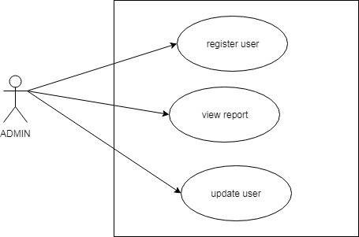

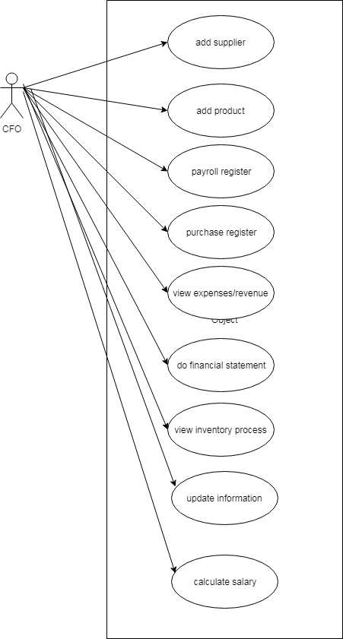

CFO-US_02,US_07,US_09,US_10,US_12,US_13,US_17,US_19,US_20,US_27

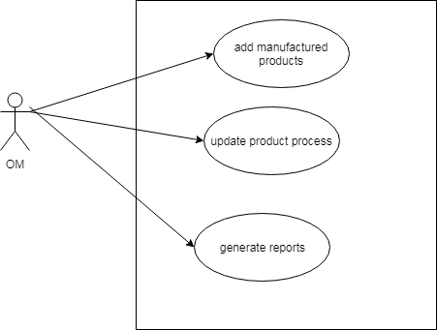

OM-US_30,US_31,US_29

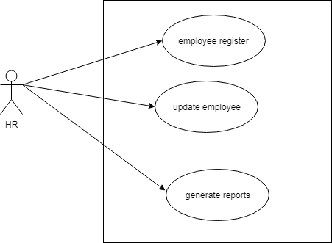

HR-US_01,US_01,US_01,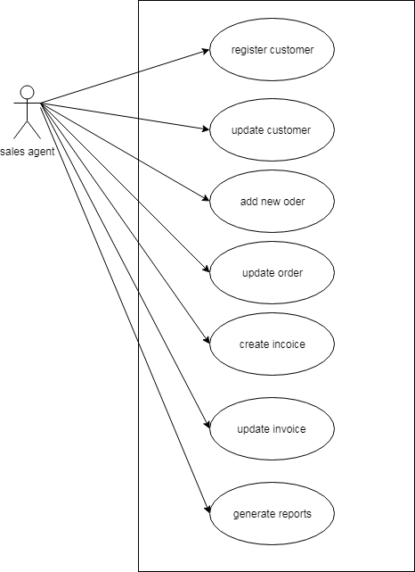

## Sales agent-US_04, US_06, US_21, US_23, US_24, US_26, US_29,C:\Users\user\AppData\Local\Microsoft\Windows\INetCache\Content.Word\add employee.pngC:\Users\user\AppData\Local\Microsoft\Windows\INetCache\Content.Word\add product.pngadd client

AD_14

AD_ 17

AD_04

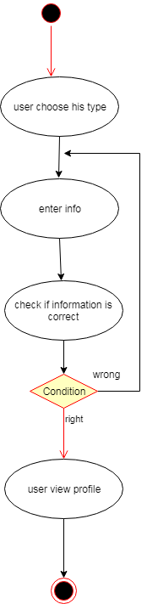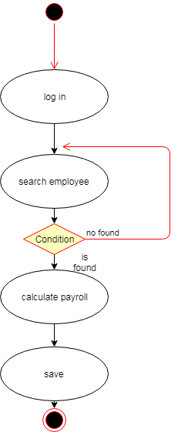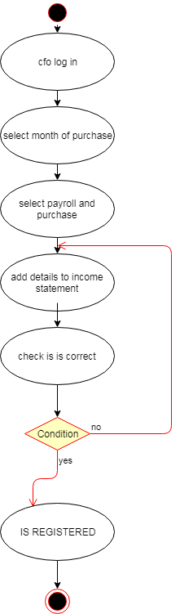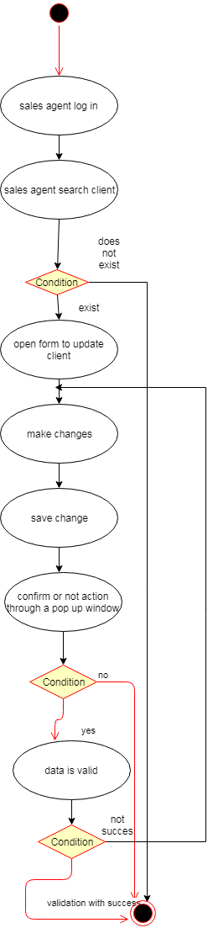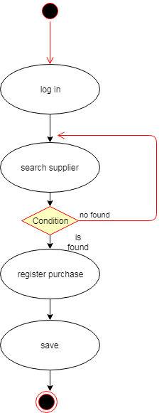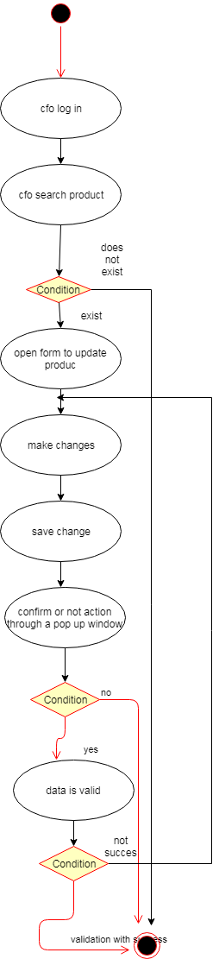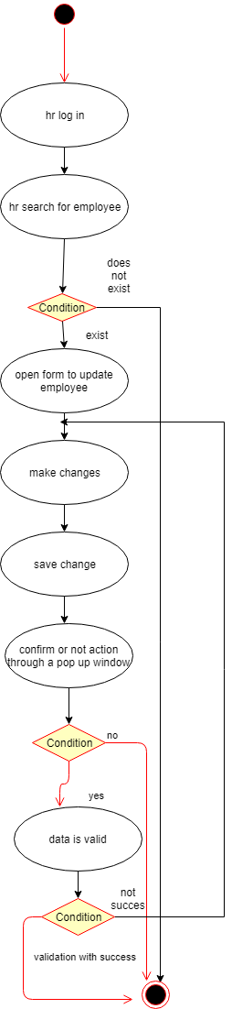

AD_27

AD_02

AD_20

AD_06

AD_10

AD_19

AD_ 26

## State Diagrams

### Admin

### 

SD_ 1, SD_33

### CFO

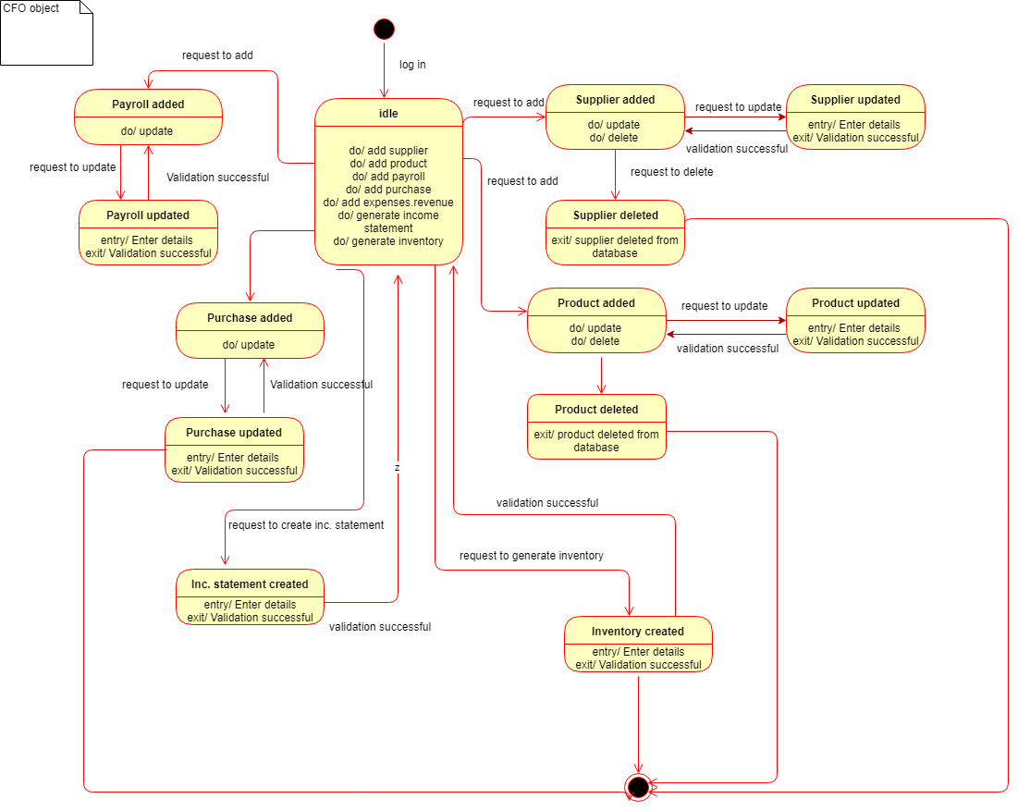

SD_07, SD_09, SD_10, SD_12, SD_13, SD_14, SD_17, SD_19, SD_20, SD_27

### HR state

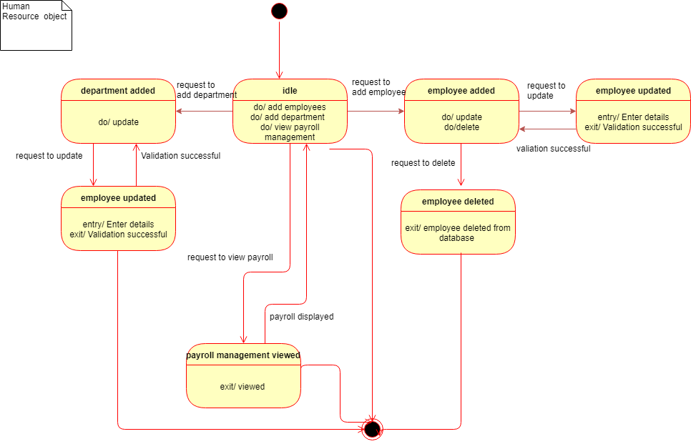

SD_14. SD_16, SD_34, SD_35

### Sales agent

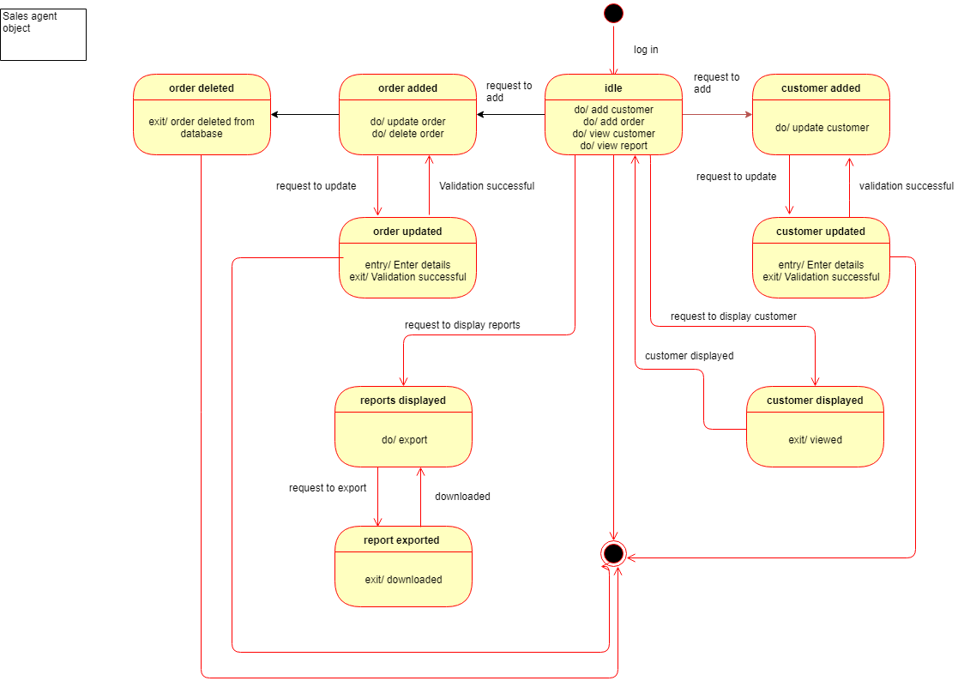

SD_ 04, SD_06, SD_21, US_23, US_29

### Operations’ manager

## 

SD_ 30

## Sequence diagrams

### Create income statement

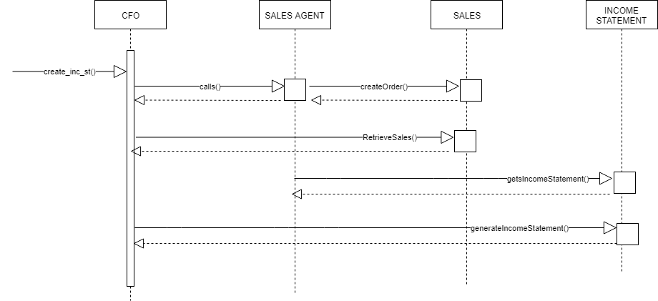

SC_20

### Access Inventory DiagramCreate inventoryCollaboration diagrams

SC_13

### Generating income statement

### 

CD_20

### Access inventory

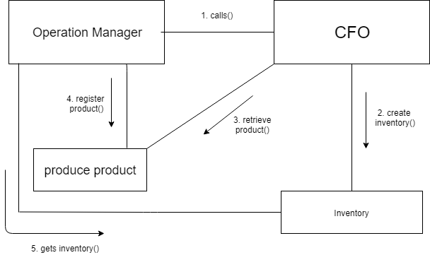

CD_13

## Data Flow Diagram:



### DFD- Level 0

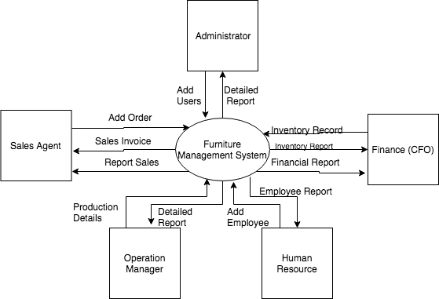

DFD_ Level 0

### DFD - Level 1

:User

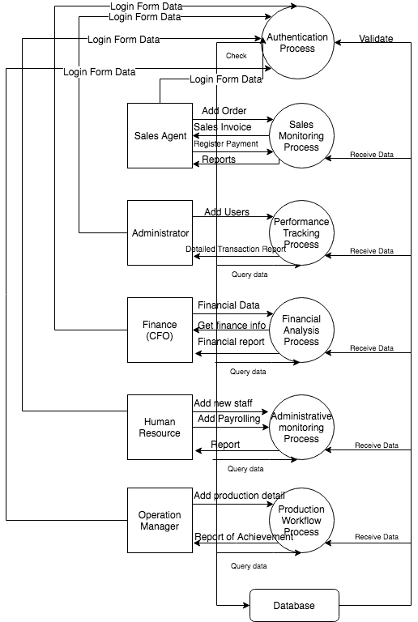

DFD_Level 1

### DFD - Level 2

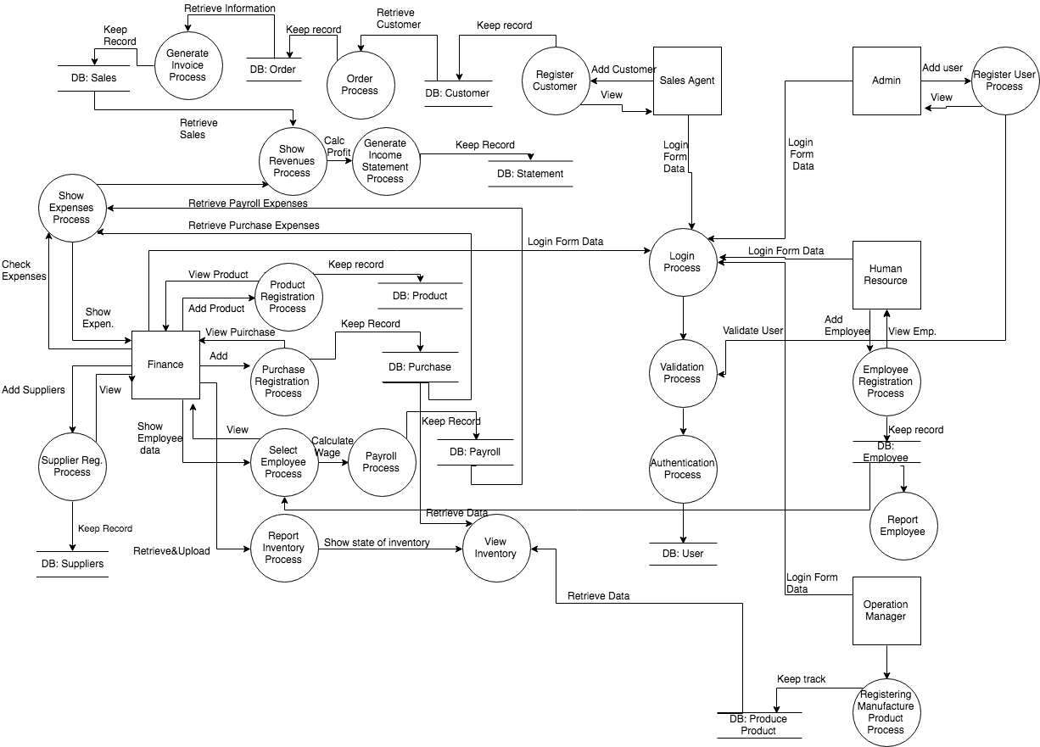

DFD_ Level 2

## Entity Relationship Diagram

### Entity Relationship Diagram without attributes

ERD_ 1

### **Entity Relationship Diagram with attributes**

ERD_

## Class diagram

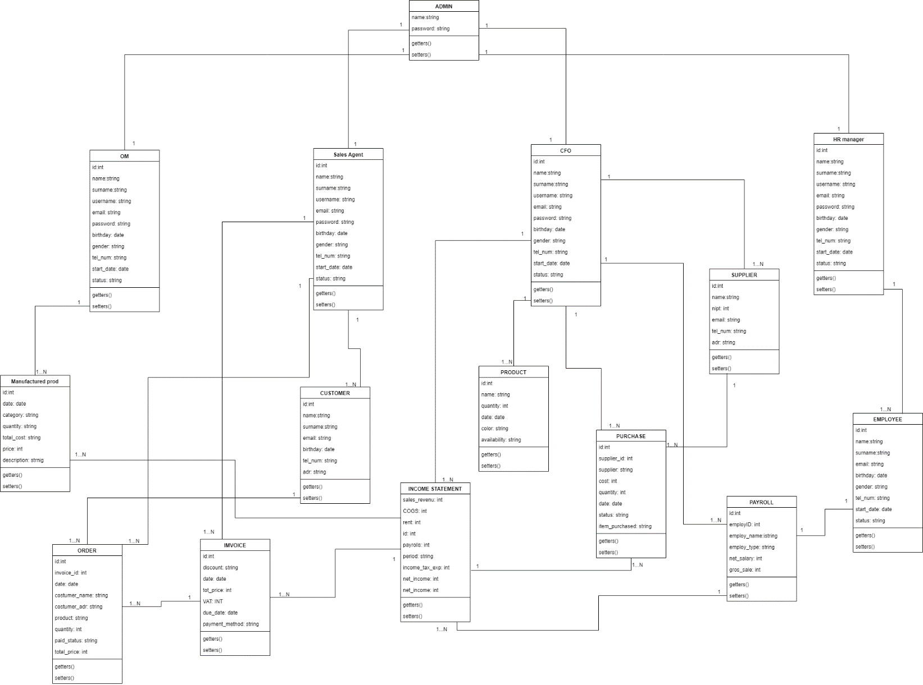

CsD_ 1

## Object diagram

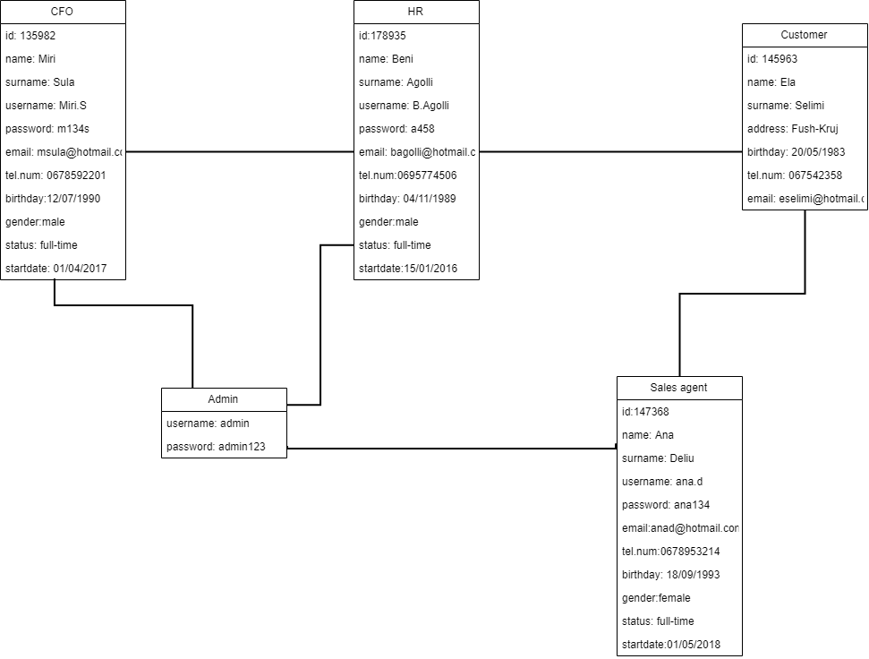

OD_ 1

## Deployment diagram

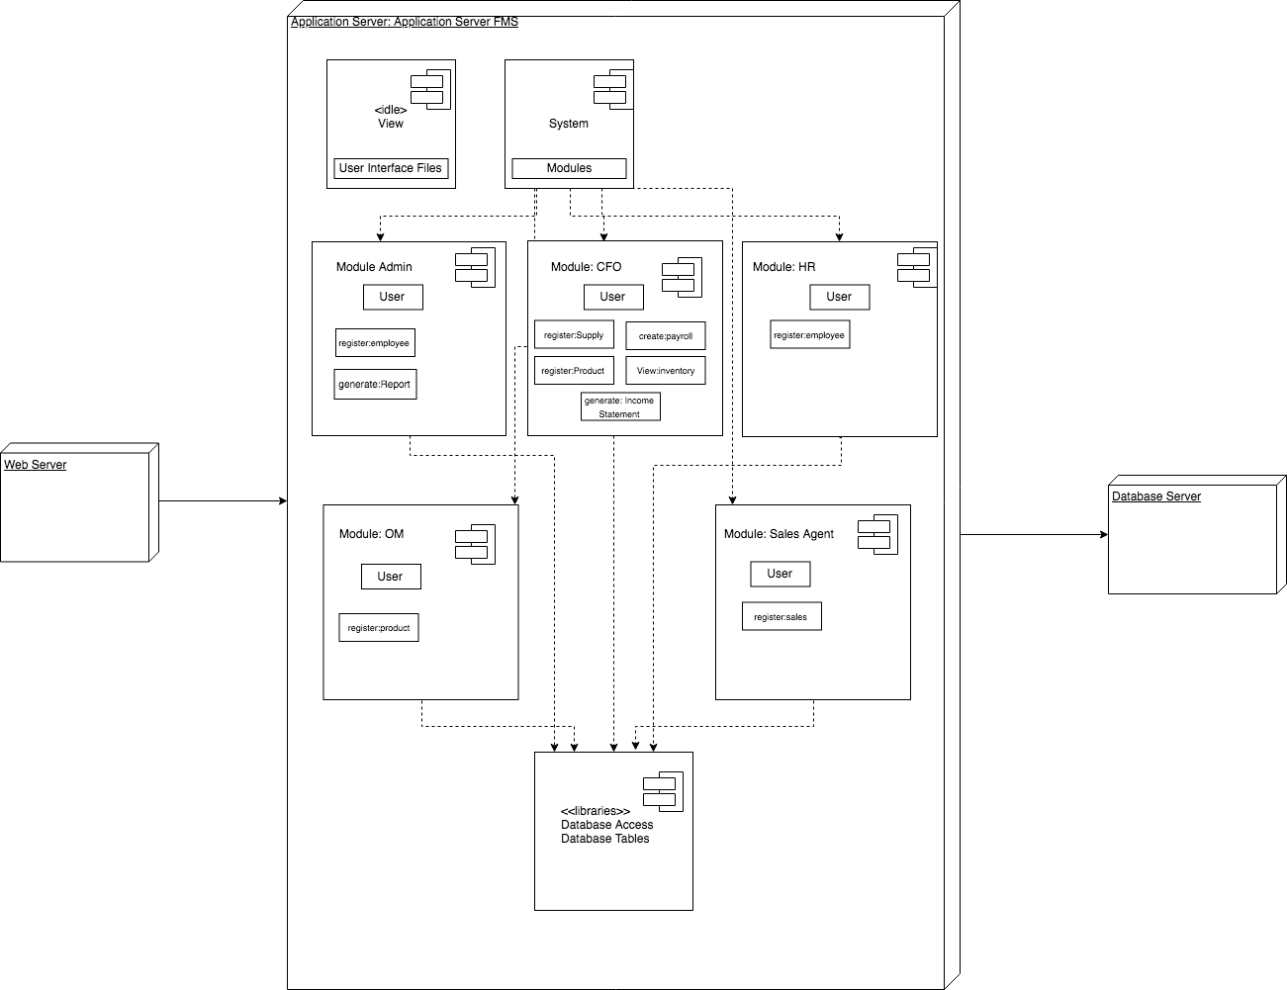

DD_ 1

## Component diagram

CoD_ 1

# IMPLEMENTATION

Implementation is the realization of an algorithm in a program, software or other application. This is achieved through computer programming and development. There are a set of interrelated tasks that must be accomplished in order for the system to be implemented successfully. Therefore, choosing the adequate technology for the system is one of the most important parts of the whole project. There is not a specific technology that makes the perfect implementation; however, it is crucial to focus on the client's requirements and the purpose to which the software is built.

## 7.1 Technologies used

This system is written in PHP. This language was chosen due to the fact that it is user friendly and it is the most widely used language for web applications. It offers many functionalities with little and simple coding. It is flexible meaning that it made it easier to us to adapt to client’s requirements. Furthermore, it made possible the connection of the application with the database as it helps web applications fully use the web server and the MySQL database.

However, to make possible every part of the system, it was necessary using some other technologies that are crucial for the user interface part. All of them shall be explained below.

## 7.2 HTML

HTML is the acronym for Hypertext Markup Language. It is not a programming language, but it is a markup one used for structuring web pages. It tells the web browser how to view these web pages. In short words, it contains the building elements of all web applications in the internet. Some elements, also used in this application, are div, p for paragraph, heading from h1 to h6, tables and inputs of all types used for registration forms. In order to make the interface more attractive, the HTML elements are given a CSS or Bootstrap class, which will stylize the page.

## 7.3 CSS

## CSS is the abbreviation for Cascading Style Sheet. It is used to stylize the HTML elements by creating a more attractive interface to the user. It holds properties that change the layout of the page, font size and colour, adds images and background colors. Moreover, it changes padding and margins of the page.

## 7.4 JavaScript

JavaScript, also known as JS, is a programming language used for web development. It enables interactive pages and it is a crucial part of web applications. It has curly brackets syntax; object oriented based programming style and it supports event-driven and functional programming methods.

In our code JS was mostly used to help with the Bootstrap templates to make the web pages more responsive.

## 7.5 Bootstrap

Bootstrap is a free CSS framework used for front-end web development. It mainly contains templates for navigation bars, layout, grids buttons and many other elements. It is rather advanced and it helps a lot with the responsiveness of web pages.

The main component of Bootstrap is called "container" as everything is placed inside it. Another element used in our coding is division of columns and grid layout.

1. **Project Planning**

Project Name: Furniture Management System

Members: Dhimitraq Stambolliu, Eda Muka, Goldena Hoxhaj, Kejsi Kallmeti, Marina Piro, Pulia Letizia Naska

Real start and end days: 11.03.2019 – 04.06.2019

Estimated start and end days: 13.03.2018 – 16.07.2019

Real total days: 86 days

Estimated total days: 101 days

Network Analysis:

|  |  |  |  |
| --- | --- | --- | --- |
| **Nr** | **Project Type** | **Duration** | **Dependency** |
| 1 | Deciding Project Type | 7 days | - |
| 2 | Discuss module of project | 5 days | 1 |
| 3 | Project Description | 8 days | 2 |
| 4 | Sketch Design | 7 days | 3 |
| 5 | Functional Requirements  Non – Functional Requirements | 13 days | 3 |
| 6 | User Scenario  Use Cases | 10 days | 4, 5 |
| 7 | Activity Diagram  State Diagram  Data Flow Diagram  ERD | 12 days | 6 |
| 8 | Sequence Diagram  Collaboration Diagram | 8 days | 7 |
| 9 | Class Diagram  Object Diagram  Deployment Diagram  Component Diagram | 12 days | 8 |
| 10 | Code Generation | 18 days | 6, 7, 8, 9 |
| 11 | Testing | 5 days | 10 |
| 12 | Project Management | 3 days | 11 |

**Networks:**

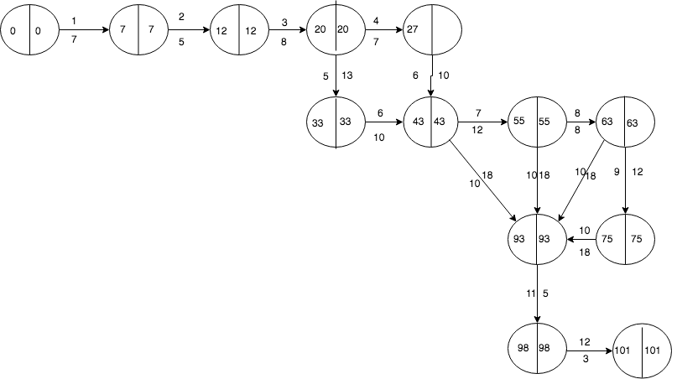

33

**Stage Plan (Gantt Charts):**

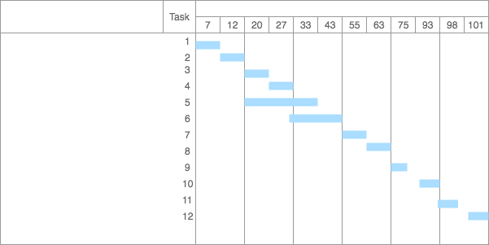

1. **Future Work**

We have built this web application based on the requirements of a furniture company here in Albania. So according to the future work we have thought to implement this management system for this company but before adding some new features.   
In the web application is missed the print format of the invoice from the sales agent, so we thought to add this in the future work. Another functionality that we might be working would be also including more financial statement such as Balance sheet. So, in the sector of the CFO can be added more information about the assets that the company owns.

**APPENDIX**

1. Definitions, Acronyms, and Abbreviations  
   AD_## - Activity Diagram followed by a number   
   CD_## – Collaboration Diagram followed by a number  
   CsD_## – Class Diagram followed by a number  
   CoD_## – Component Diagram followed by a number  
   DD – Deployment Diagram  
    DFD_## - Data Flow Diagram followed by a number   
   ERD_## – Entity Relation Diagram  
   BR_## - Business Requirement followed by a number   
   OD_## – Object Diagram followed by a number   
   PDF – Portable Document Format   
   SD_## - State Diagram followed by a number  
    ScD_## - Sequence Diagram followed by a number   
   UC_## - Use Case followed by a number  
    UI – User Interface   
   US_## - User Scenario followed by a number   
   XML – Extensible Markup Language
2. Requirements Traceability Matrix

The following trace matrix examples show one possible use of naming standards for deliverables (FunctionalArea-DocType-NN). The number has no other meaning than to keep the documents unique. For example, the Bargaining Unit Assignment Process Flow would be BUA-PF-01.

For example (1):

| **Business Requirement** | **Area** | **Deliverables** | **Status** |
| --- | --- | --- | --- |
| BR_LR_01  The system should validate the relationship between Bargaining Unit/Location and Job Class.---Comments: Business Process = "Assigning a Bargaining Unit to an Appointment" (Priority 1) | BUA | BUA-CD-01  Assign BU Conceptual Design | Accepted |
| BUA-PF-01  Derive Bargaining Unit-Process Flow Diagram | Accepted |
| BUA-PF-01  Derive Bargaining Unit-Process Flow Diagram | Accepted |
| BR_LR_09  The system should provide the capability for the Labor Relations Office to maintain the job class/union relationship.---Comments: Business Process = "Maintenance" (Priority 1) | BUA | BUA-CD-01  Assign BU Conceptual Design | Accepted |
| BUA-PF-02  BU Assignment Rules Maint Process Flow Diagram | ReadyForReview |

For example (2):

| **BizReqID** | **Pri** | **Major Area** | **DevTstItemsDelivID** | **Deliv Name** | **Status** |
| --- | --- | --- | --- | --- | --- |
| BR_LR_01 | 1 | BUA | BUA-CD-01 | Assign BU Conceptual Design | Accepted |
| BR_LR_01 | 1 | BUA | BUA-DS-02 | Bargaining Unit Assignment DB Modification Description | Accepted |
| BR_LR_01 | 1 | BUA | BUA-PF-01 | Derive Bargaining Unit-Process Flow Diagram | Accepted |
| BR_LR_01 | 1 | BUA | BUA-UCD-01 | BU Assign LR UseCase Diagram | ReadyForReview |
| BR_LR_01 | 1 | BUA | BUA-UCT-001 | BU Assignment by PC UseCase - Add Appointment and Derive UBU | Reviewed |
| BR_LR_01 | 1 | BUA | BUA-UCT-002 | BU Assignment by PC UseCase - Add Appointment (UBU Not Found) | Reviewed |
| BR_LR_01 | 1 | BUA | BUA-UCT-006 | BU Assignment by PC UseCase - Modify Appointment (Removed UBU) | Reviewed |
| BR_LR_09 | 1 | BUA | BUA-CD-01 | Assign BU Conceptual Design | Accepted |
| BR_LR_09 | 1 | BUA | BUA-DS-02 | Bargaining Unit Assignment DB Modification Description | Accepted |
| BR_LR_09 | 1 | BUA | BUA-PF-02 | BU Assignment Rules Maint Process Flow Diagram | Accepted |
| BR_LR_09 | 1 | BUA | BUA-UCD-03 | BU Assign Rules MaintUseCase Diagram | Reviewed |
| BR_LR_09 | 1 | BUA | BUA-UCT-045 | BU Assignment Rules Maint: Successfully Add New Assignment Rule | Reviewed |
| BR_LR_09 | 1 | BUA | BUA-UCT-051 | BU Assignment Rules MaintUseCase: Modify Rule | Reviewed |
| BR_LR_09 | 1 | BUA | BUA-UCT-053 | BU Assignment Rules MaintUseCase - Review Assignment Rules | Reviewed |
| BR_LR_09 | 1 | BUA | BUA-UCT-057 | BU Assignment Rules MaintUseCase: Inactivate Last Rule for a BU | Reviewed |
| BR_LR_09 | 1 | BUA | BUA-UI-02 | BU AssignRulesMaint UI Mockups | ReadyForReview |
| BR_LR_09 | 1 | BUA | BUA-TC-021 | BU Assignment Rules MaintTestCase: Add New Rule (Associated Job Class Does Not Exist) - Success | ReadyForReview |
| BR_LR_09 | 1 | BUA | BUA-TC-027 | BU Assignment Rules MaintTestCase: Modify Rule - Success | ReadyForReview |
| BR_LR_09 | 1 | BUA | BUA-TC-035 | BU Assignment Rules MaintTestCase: Add New Rule (Associated Job Class Does Not Exist) - Error Condition | ReadyForReview |
| BR_LR_09 | 1 | BUA | BUA-TC-049 | BU Assignment Rules MaintTestCase: Modify Rule - Error Condition | ReadyForReview |

For example (3):

| **BizReqID** | **CD01** | **CD02** | **CD03** | **CD04** | **UI01** | **UI02** | **UCT01** | **UCT02** | **UCT03** | **TC01** | **TC02** | **TC03** | **TC04** |
| --- | --- | --- | --- | --- | --- | --- | --- | --- | --- | --- | --- | --- | --- |
| BR_LR_01 |  |  | X |  | X |  | X |  |  | X |  | X |  |
| BR_LR_09 | X |  |  | X |  | X |  |  | X |  | X |  | X |
| BR_LR_10 | X |  |  | X |  |  |  |  | X |  | X |  |  |
| BR_LR_11 |  | X |  |  |  |  |  |  |  |  |  |  |  |

1. Design

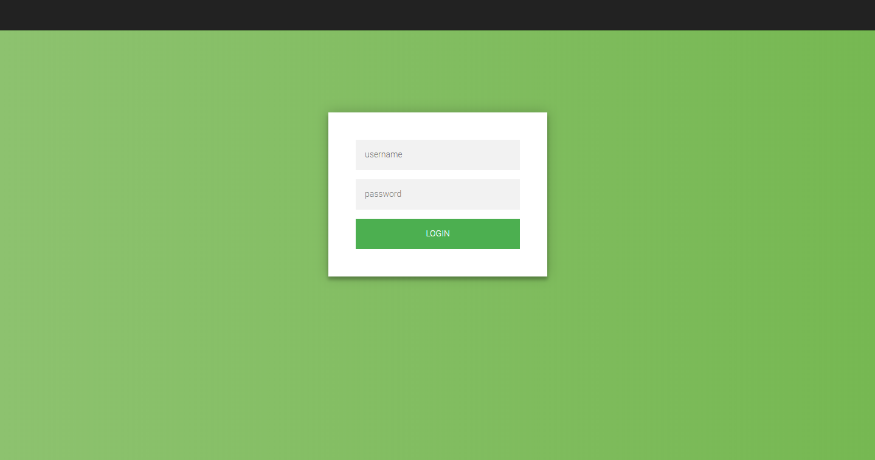

Figure 1 - LogIn Page

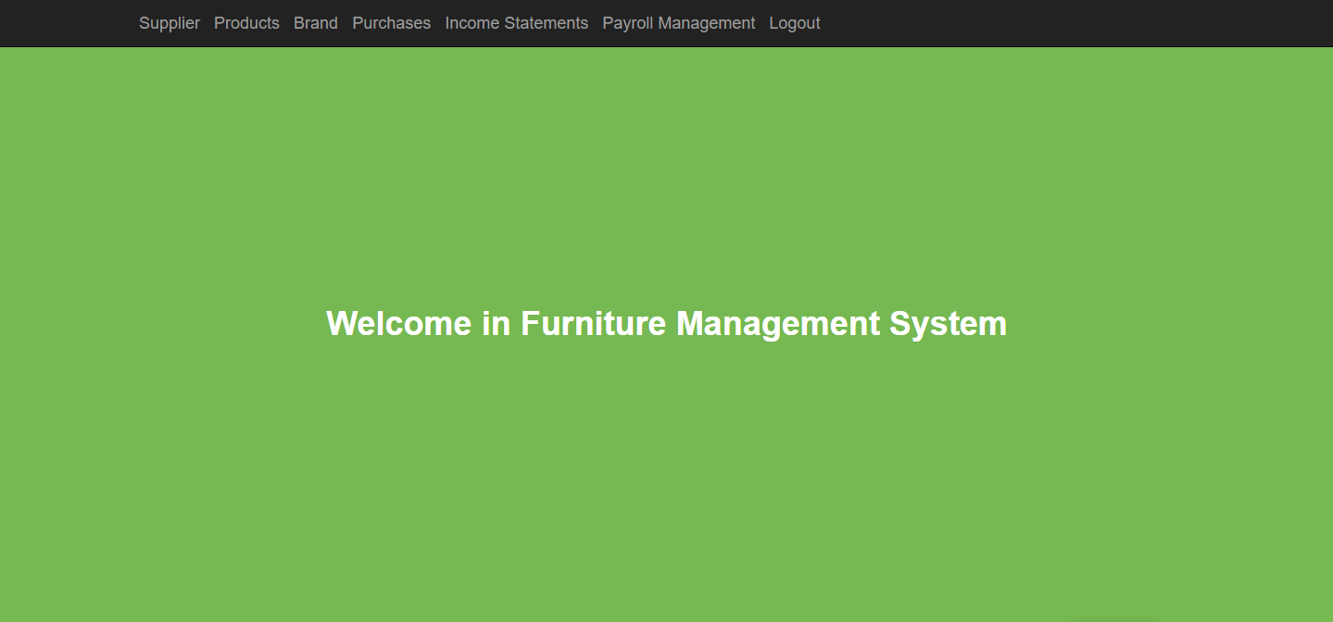

Figure 2 - Homepage of CFO

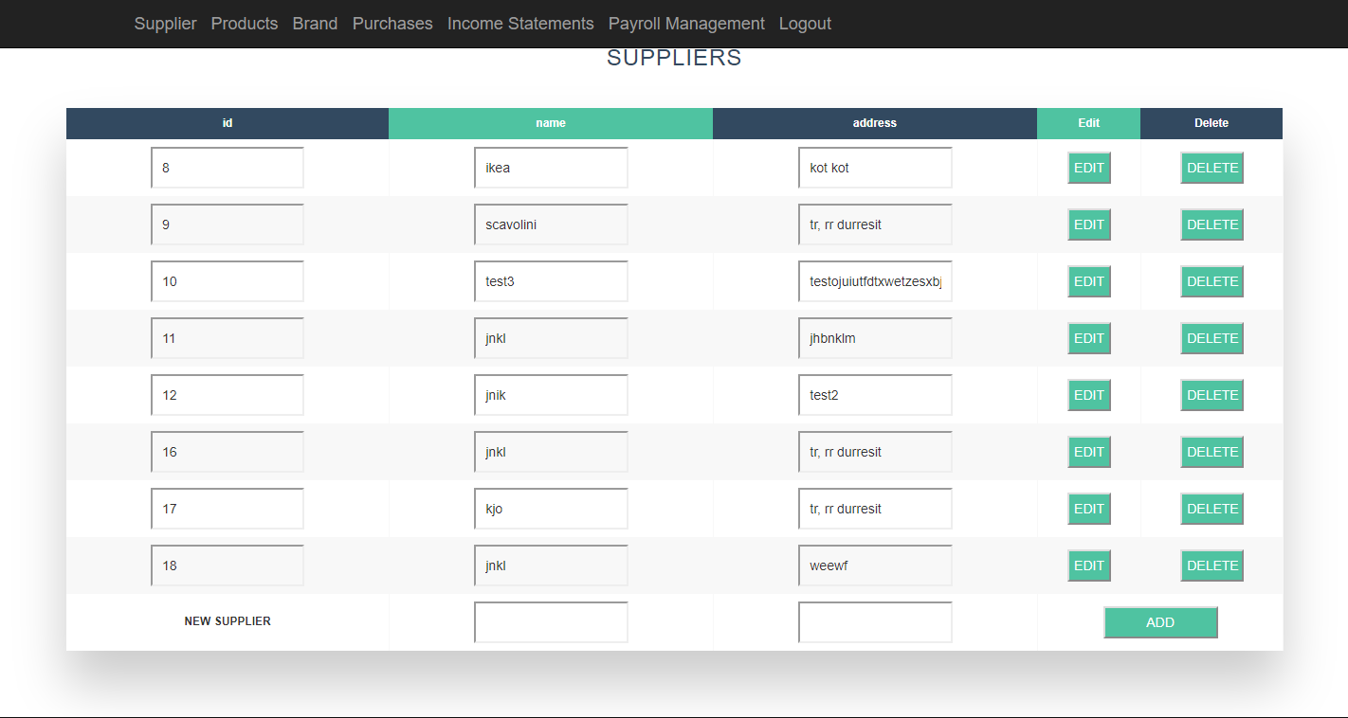

Figure 3 – Supplier section in CFO module

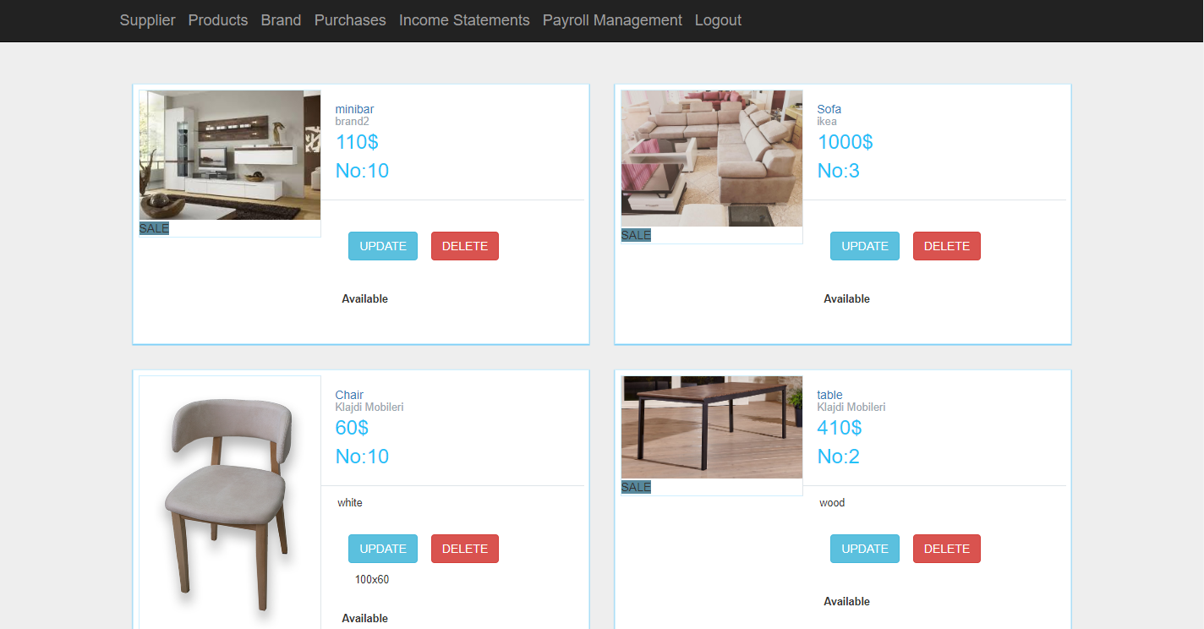

Figure 4 – Products section in CFO module

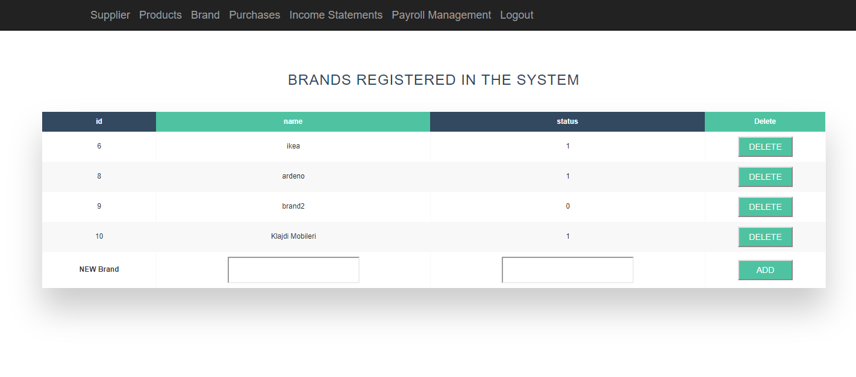

Figure 5 – Brands section in CFO module

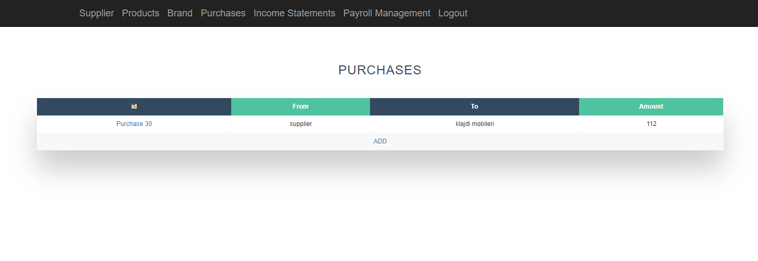

Figure 6 – Purchases section in CFO module

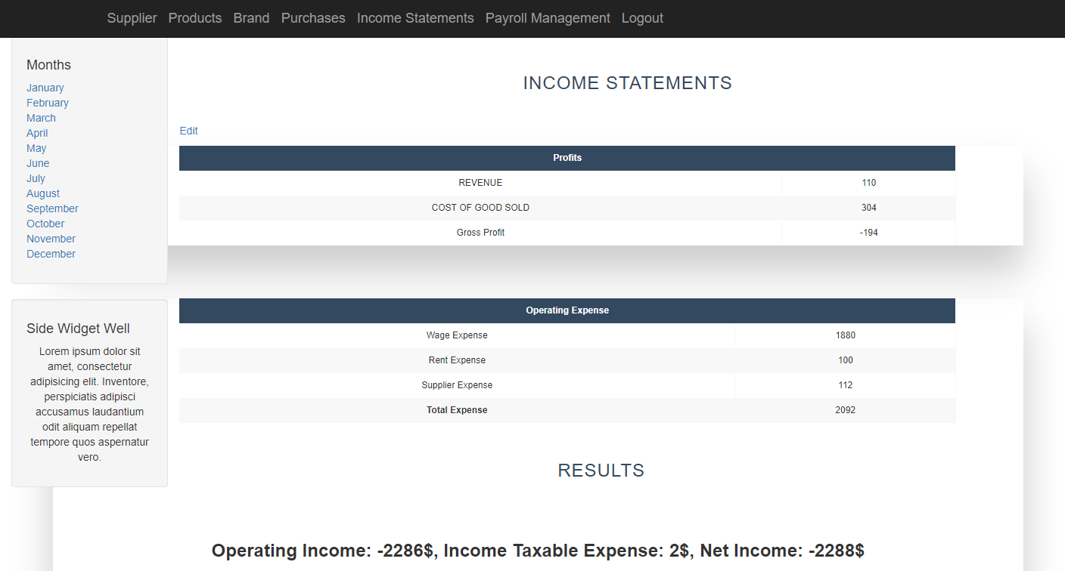

Figure 7 – Income statement section in CFO module

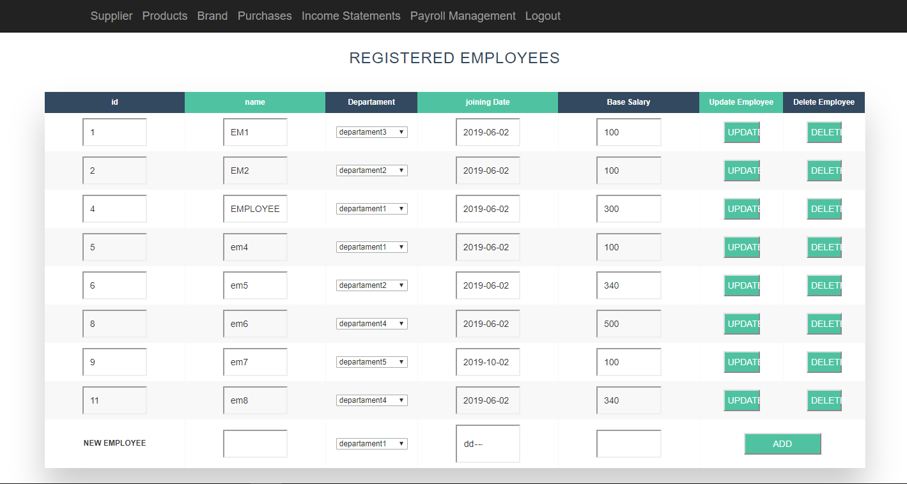

Figure 8 – Payroll management section in CFO module

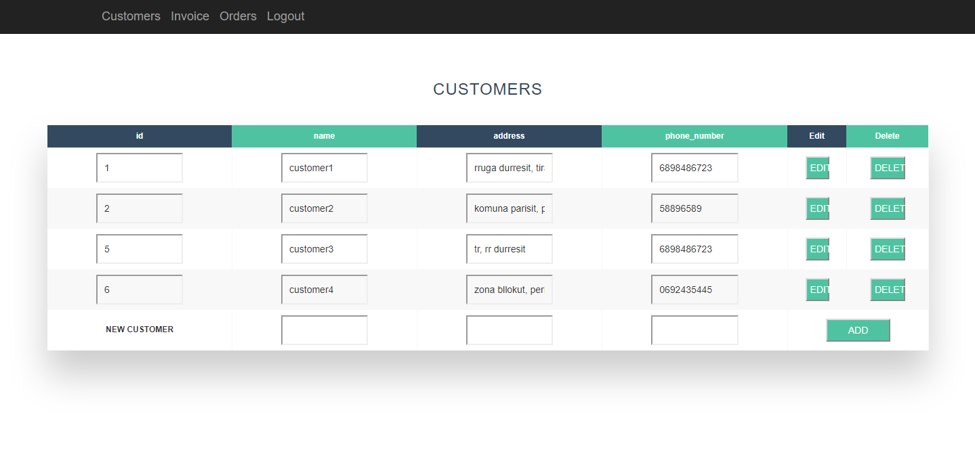

Figure 9 – Customers section in sales agent module

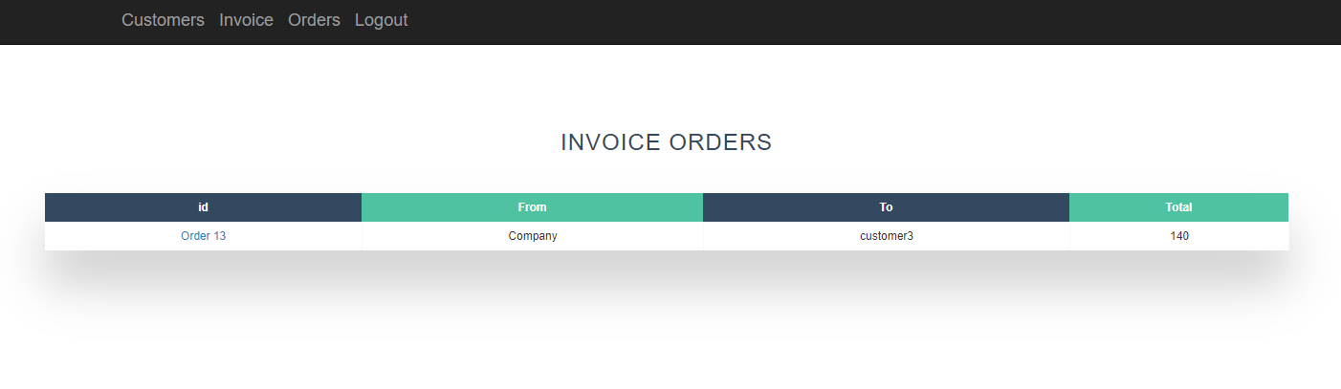

Figure 10 – Invoice section in sales agent module

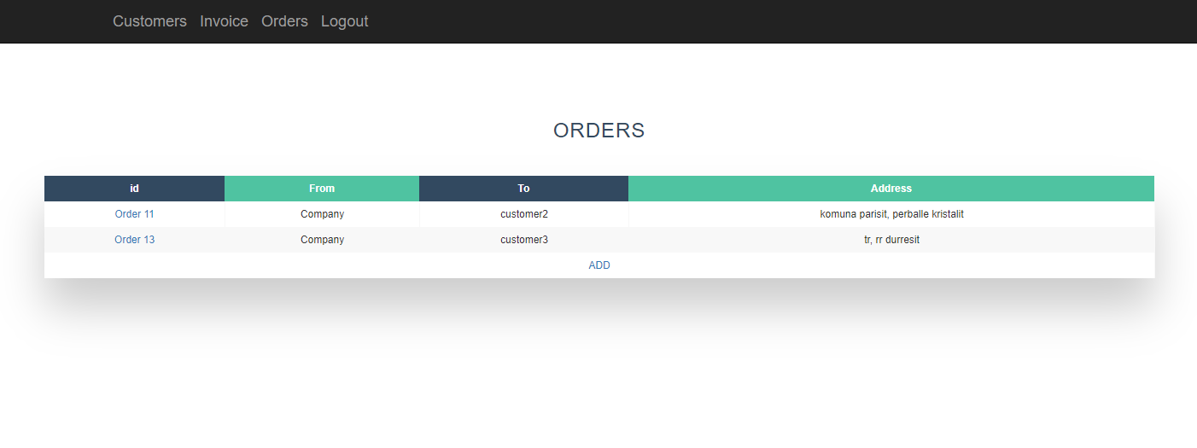

Figure 11 – Orders section in sales agent module

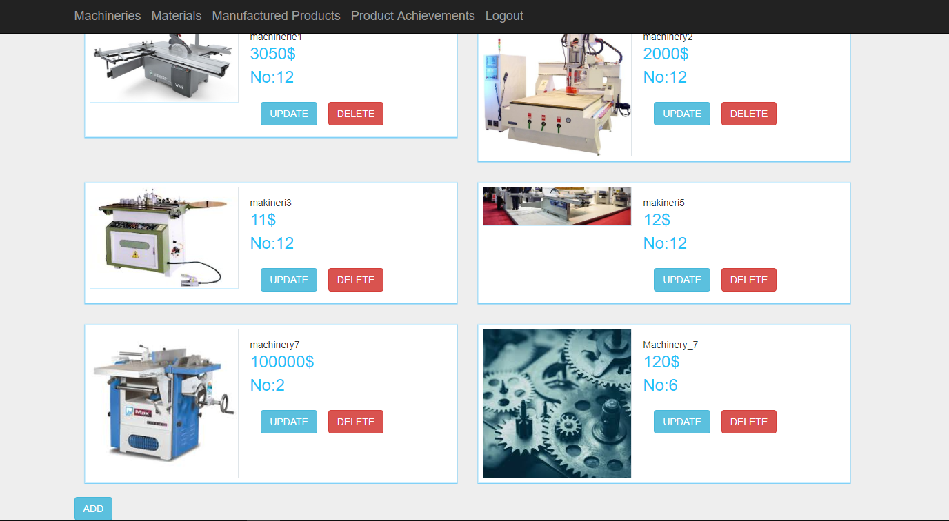

Figure 12 – Machineries section in OM module

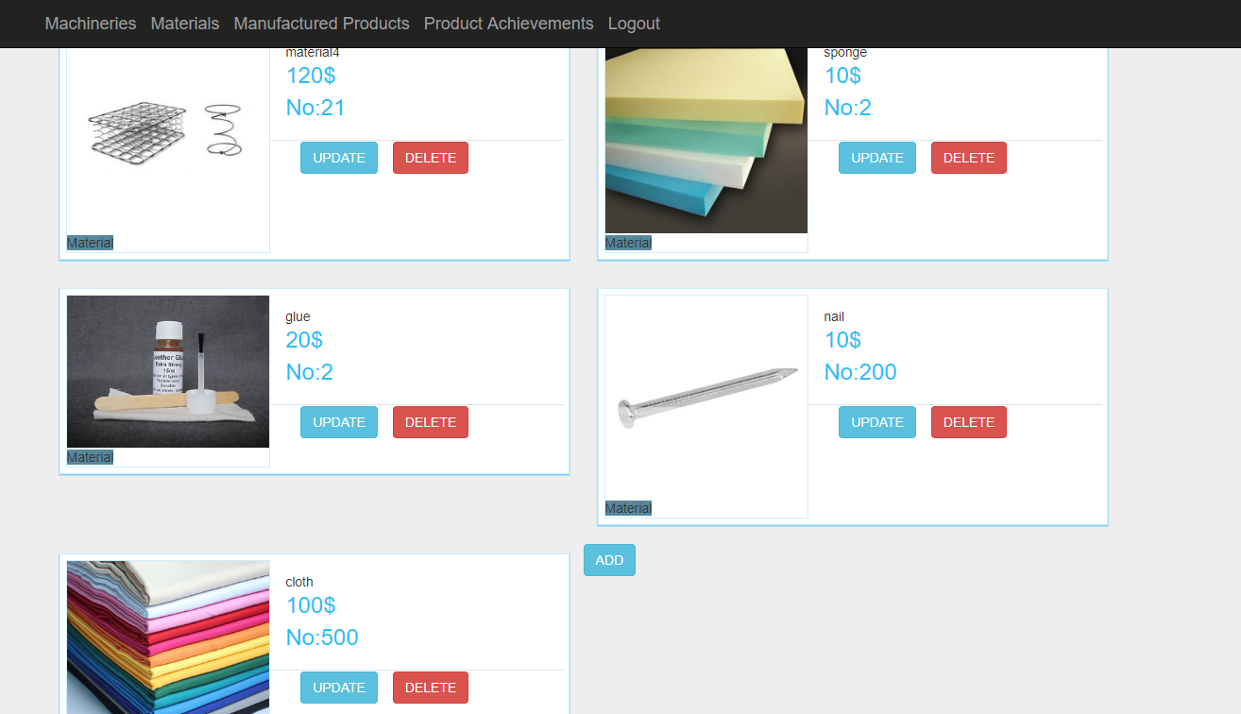

Figure 13 – Materials section in OM module

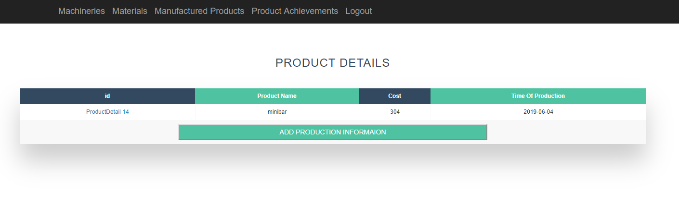

Figure 14 – Manufactured products section in OM module

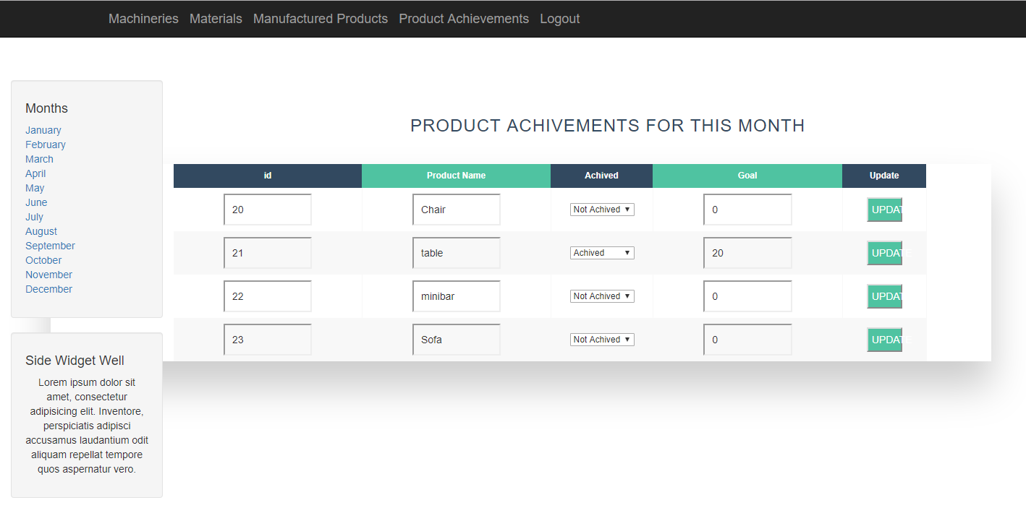

Figure 15 – Product achievements in OM module

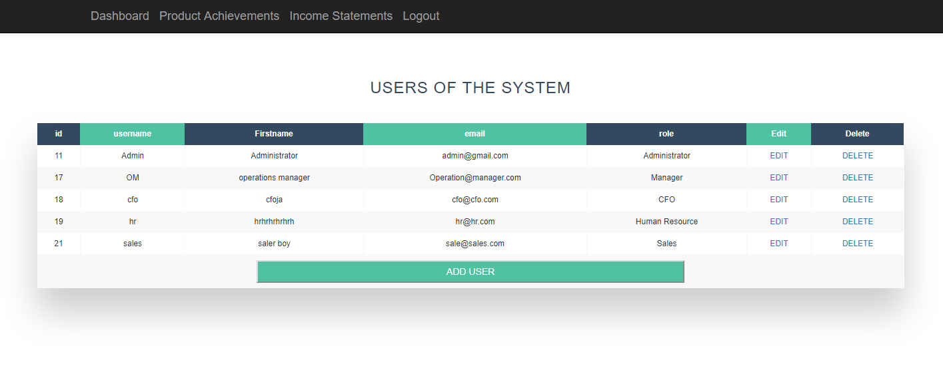

Figure 16 – Users section in admin module

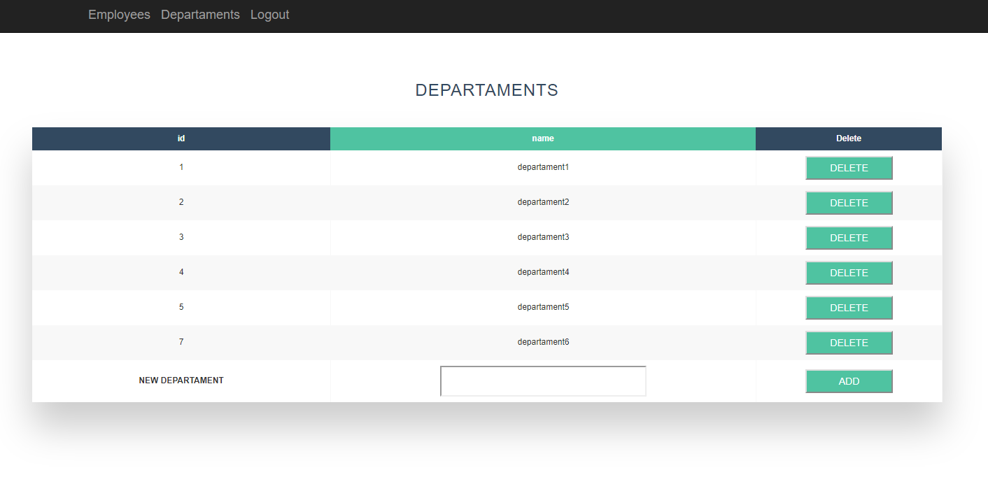

Figure 17 – Departments section in HR module

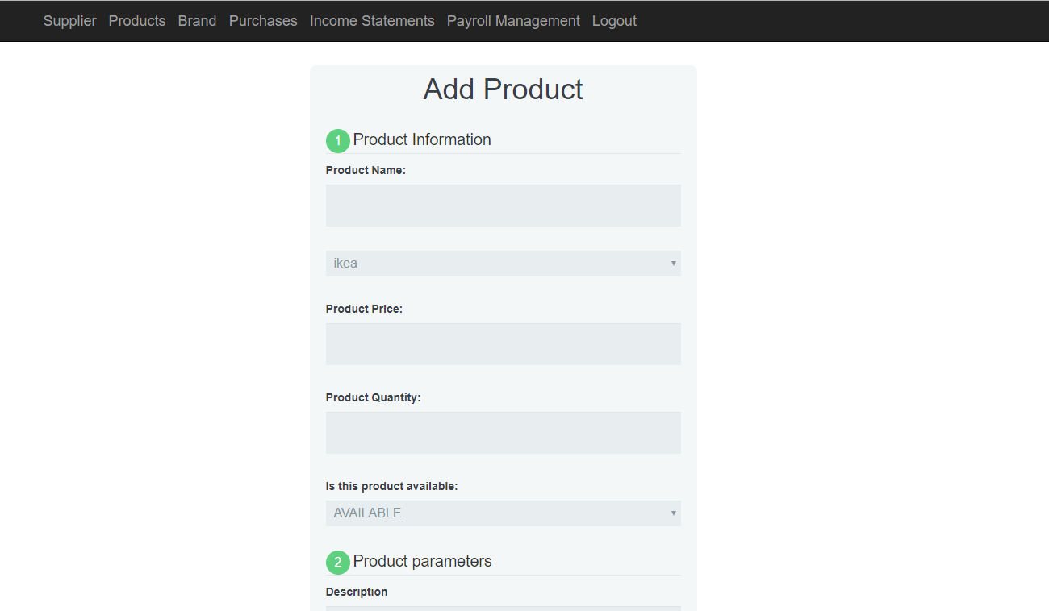

Figure 18 – Add product section in CFO module.

Similarly, are created other forms to gather data about machineries, materials, users, production details, etc.